1. Verify whether user can enter text to check the translation functionality 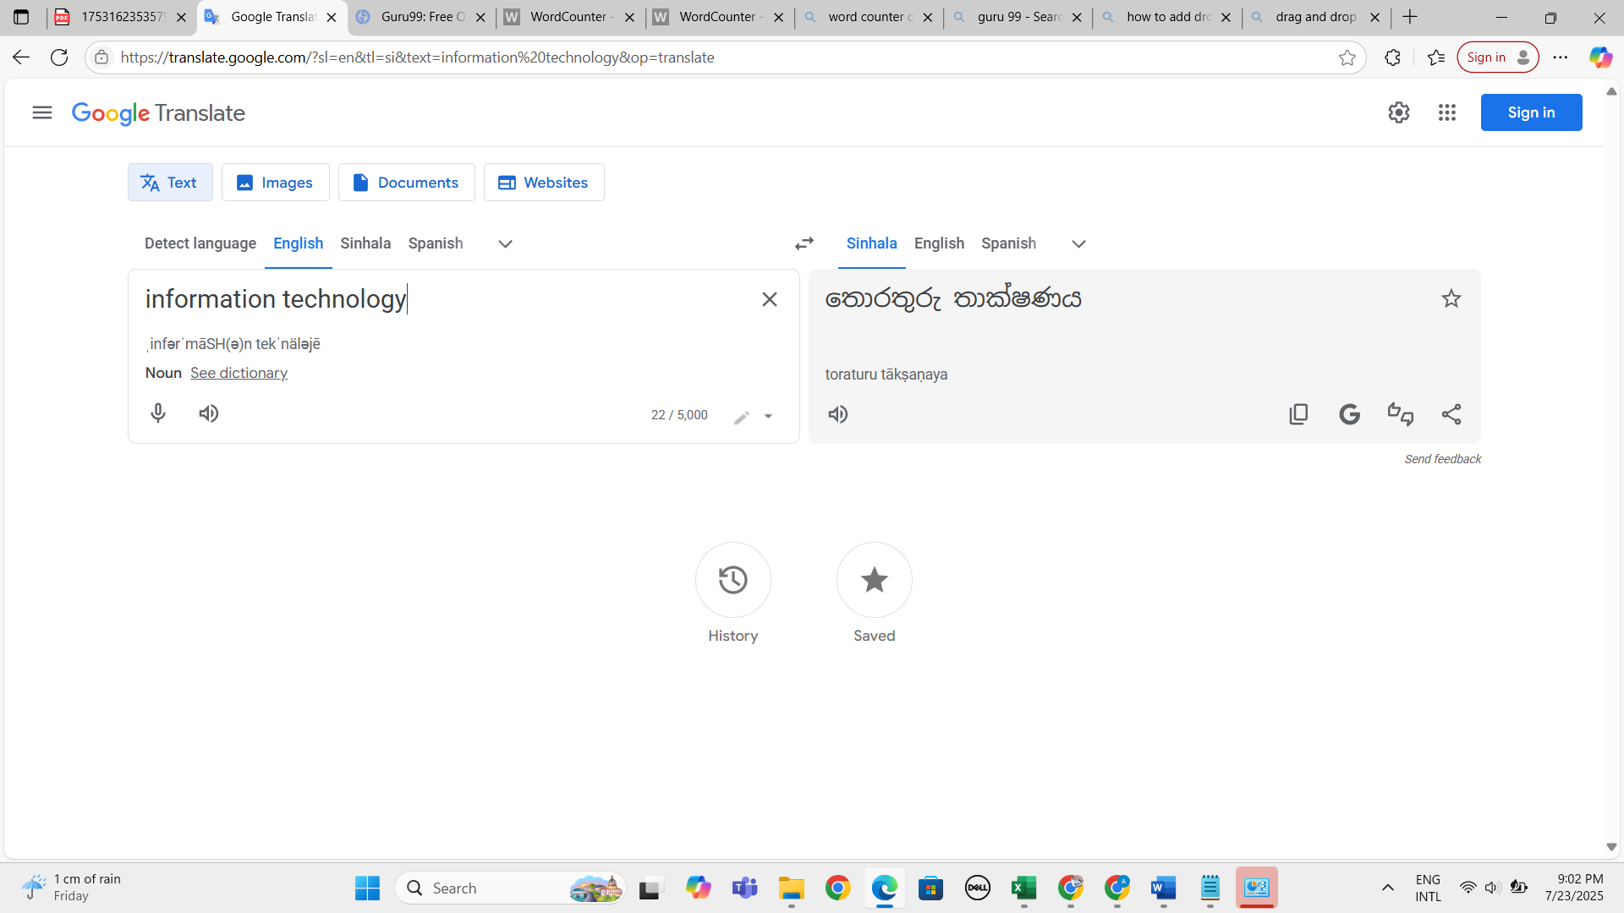
2. Verify whether user can select translation language from the drop down 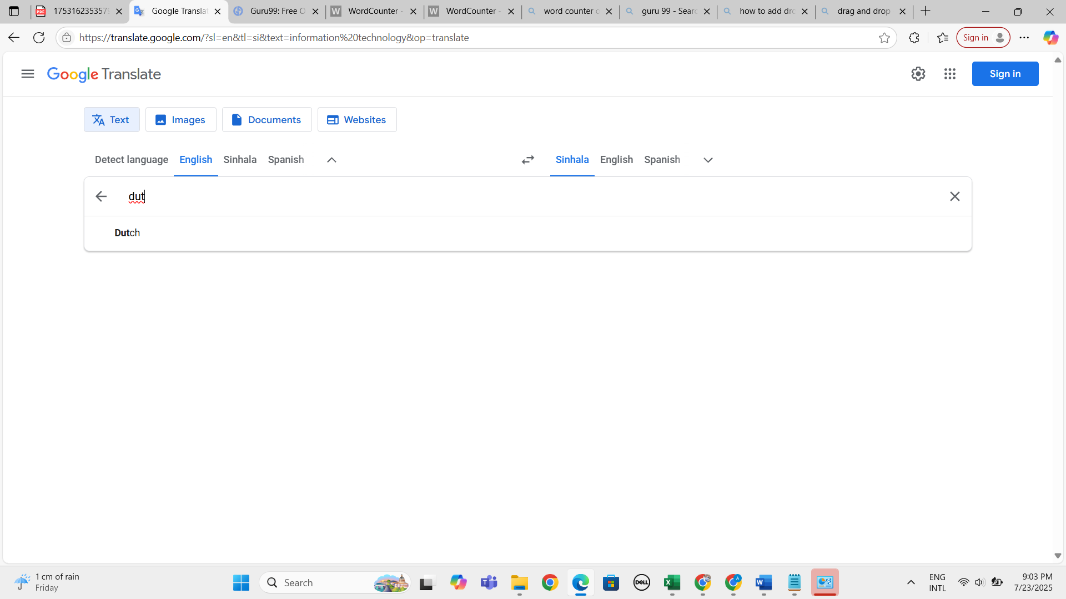 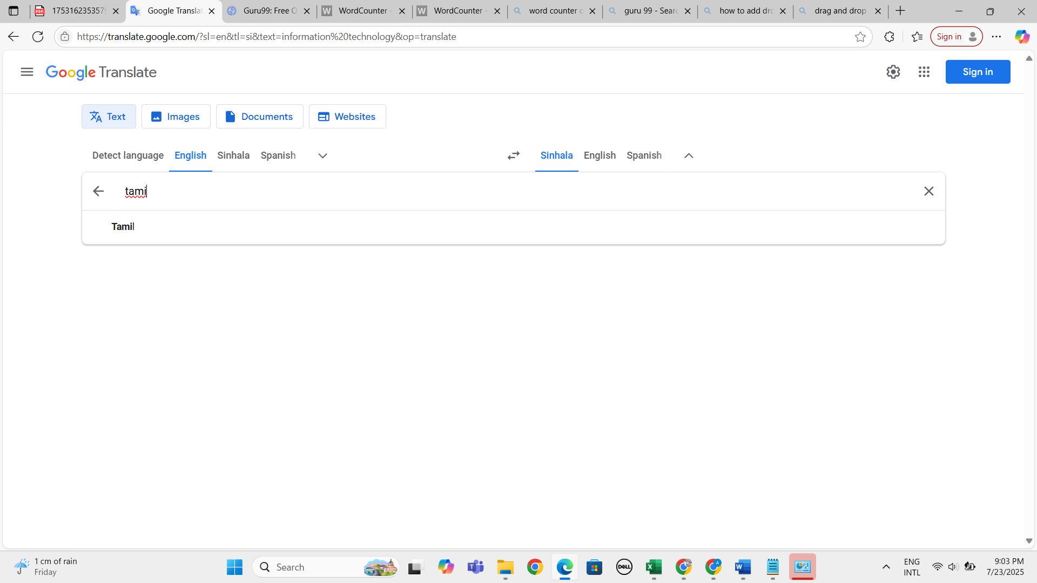
3. Verify whether system correctly display the selected languages in both sides 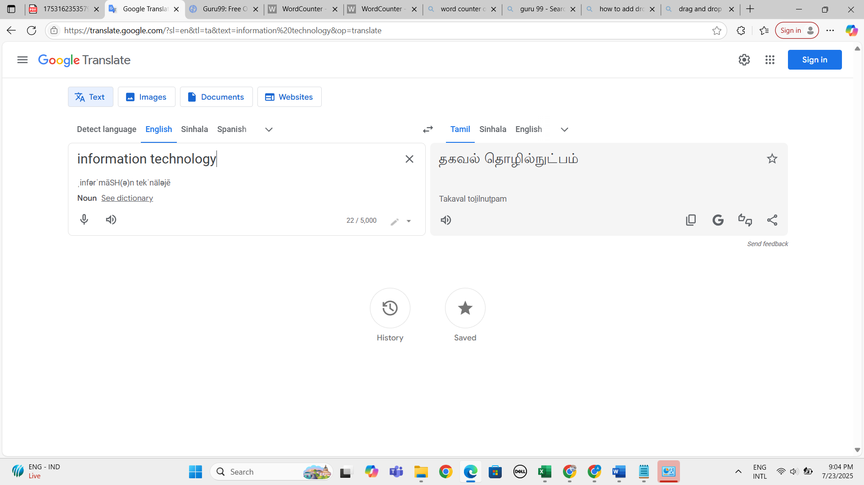
4. Verify whether system correctly display output based on the selected language 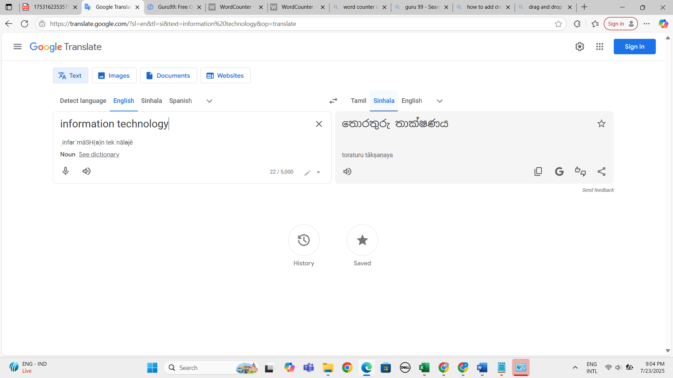
5. Verify whether user can copy and paste texts in the text box to check the translation functionality 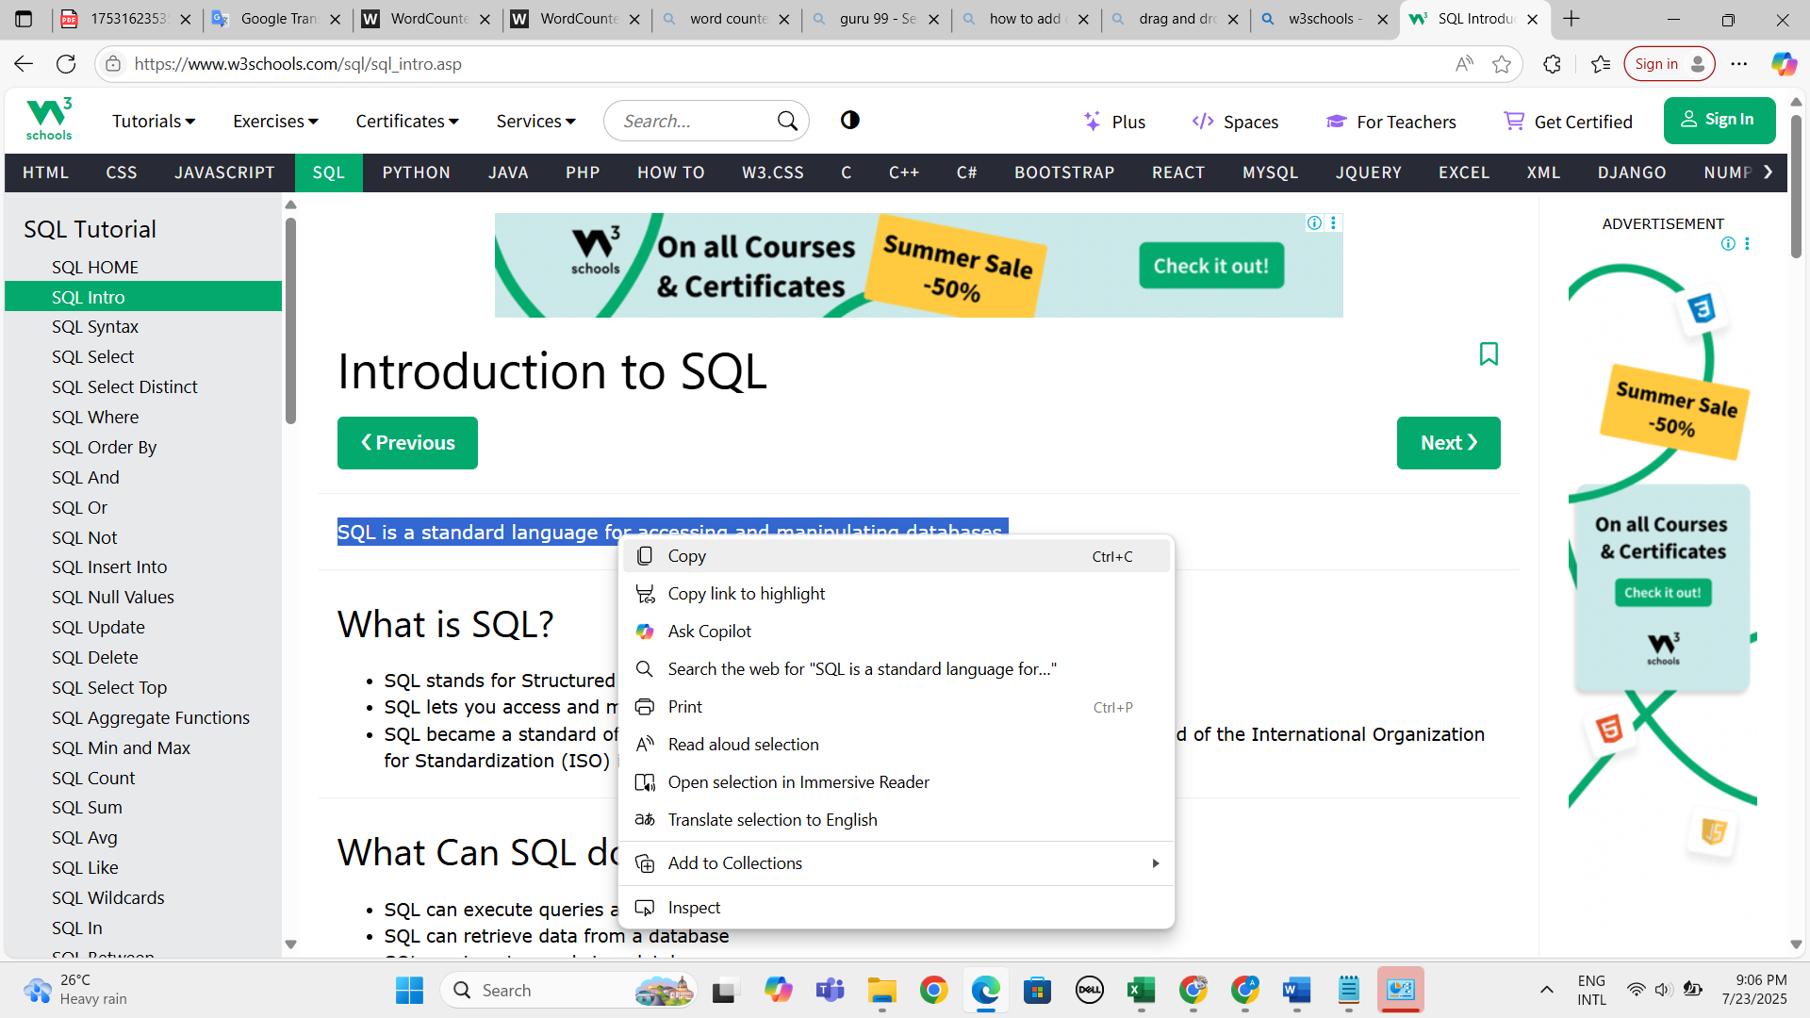 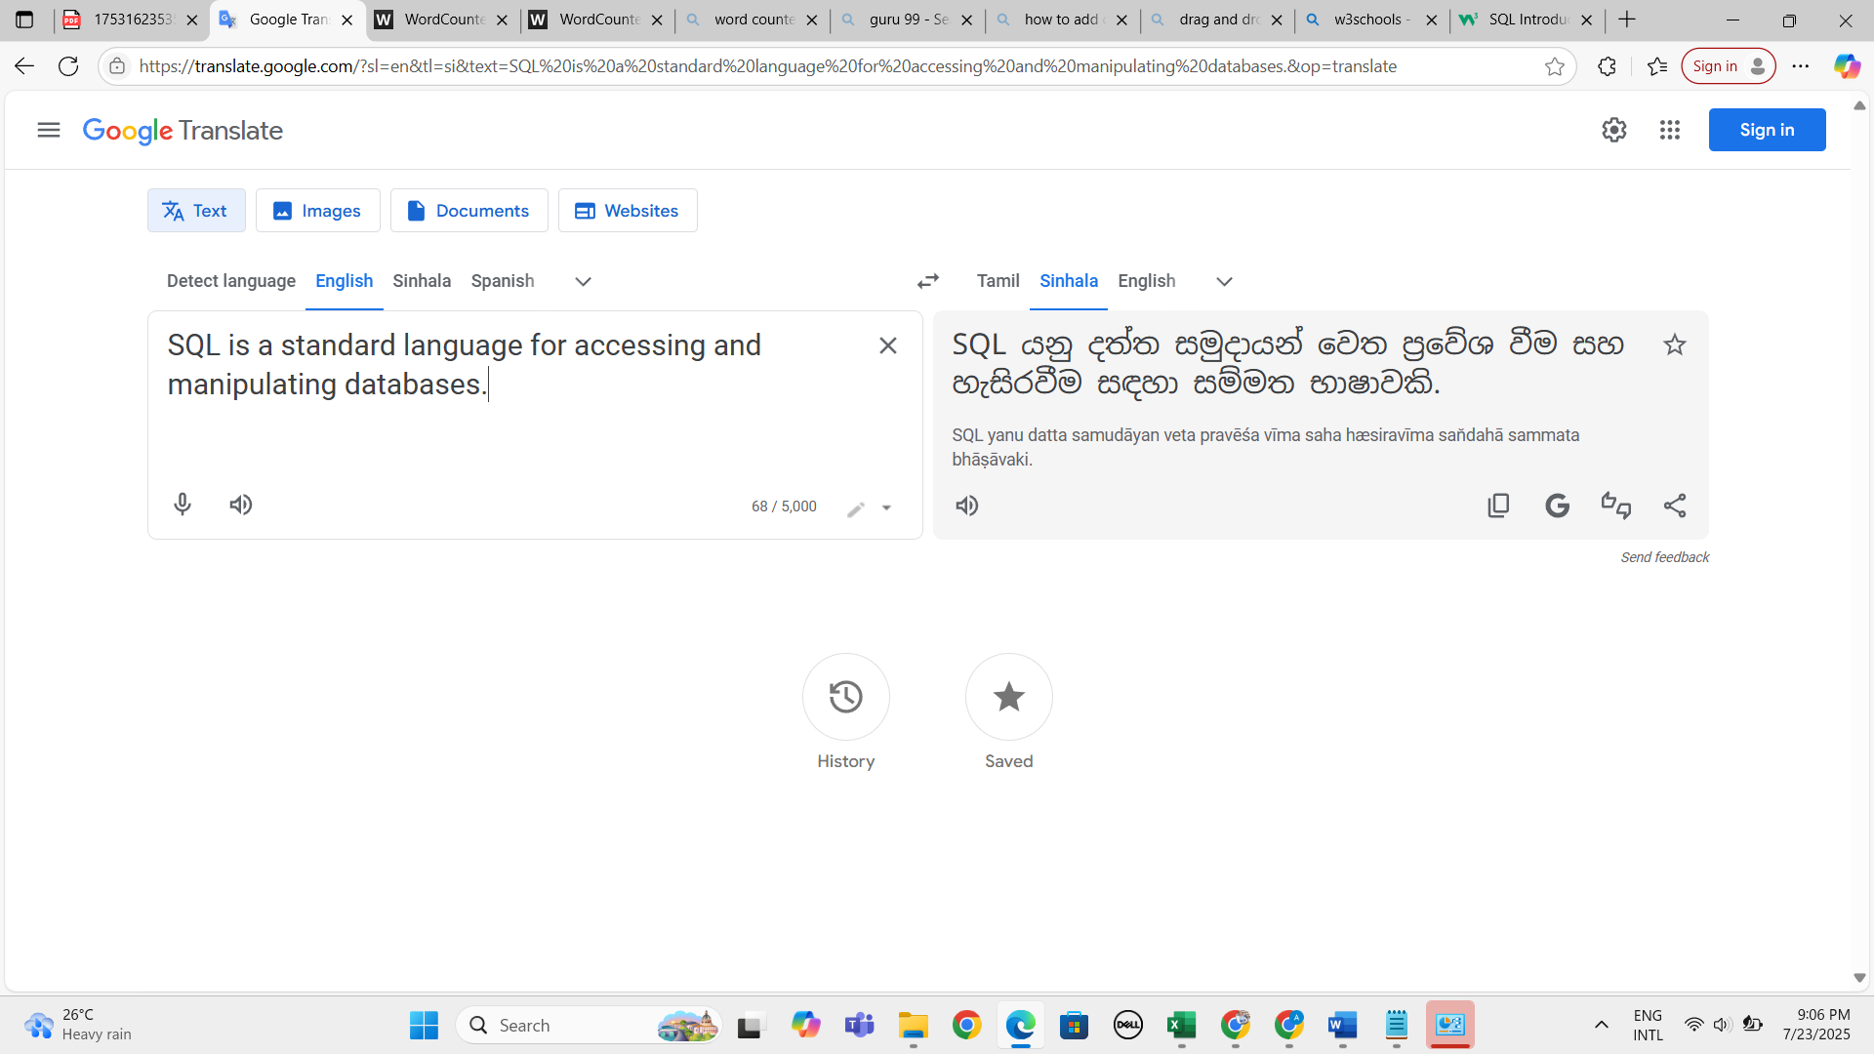
6. Verify whether user can perform translation functionality based on copy pasted text 
7. Verify whether user can listen the input and output text by clicking upon sound icon 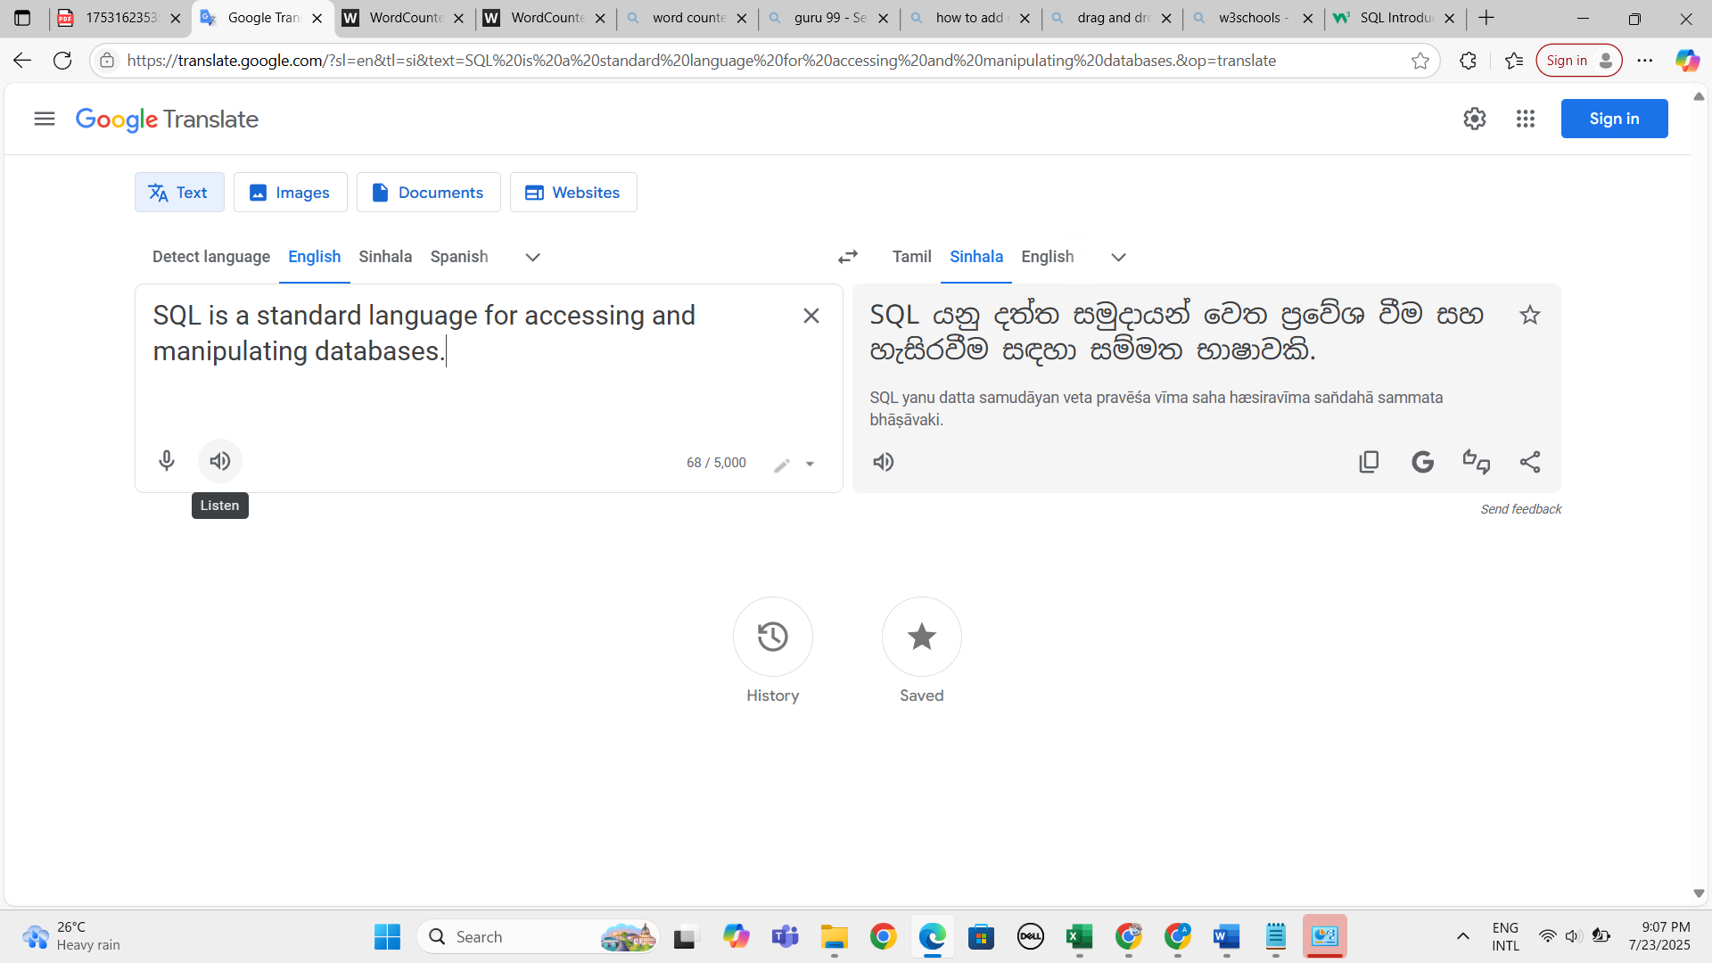
8. Verify whether user can clear the input data by clicking upon "X" icon 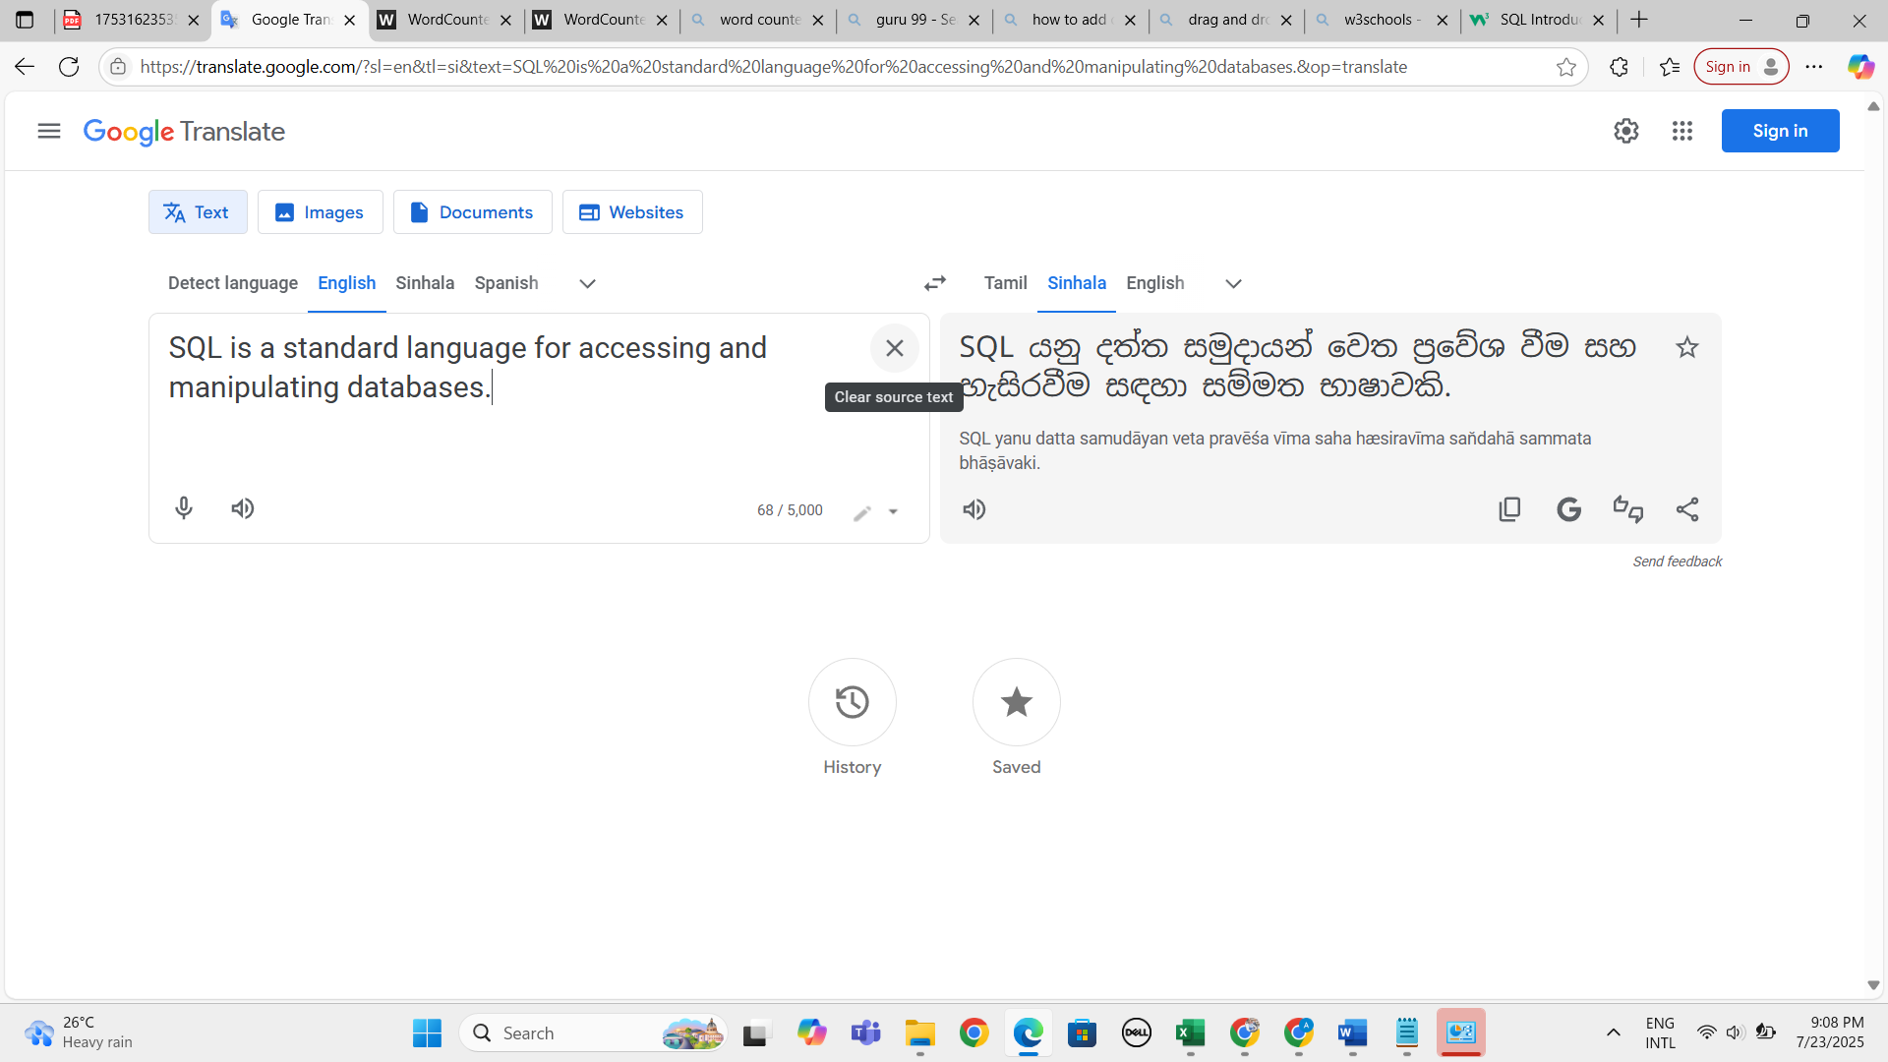 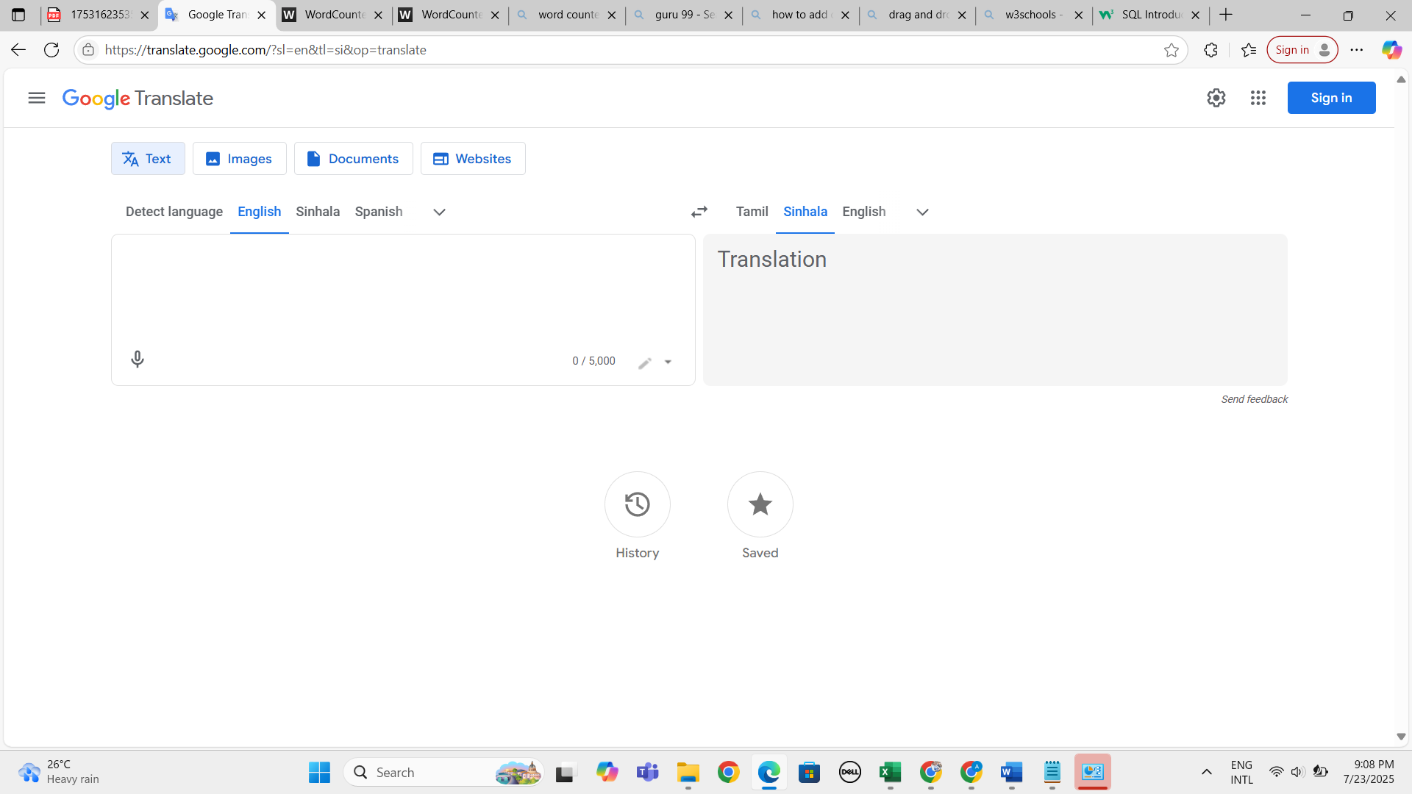
9. Verify whether user can copy the output results by clicking upon copy icon in right hand side 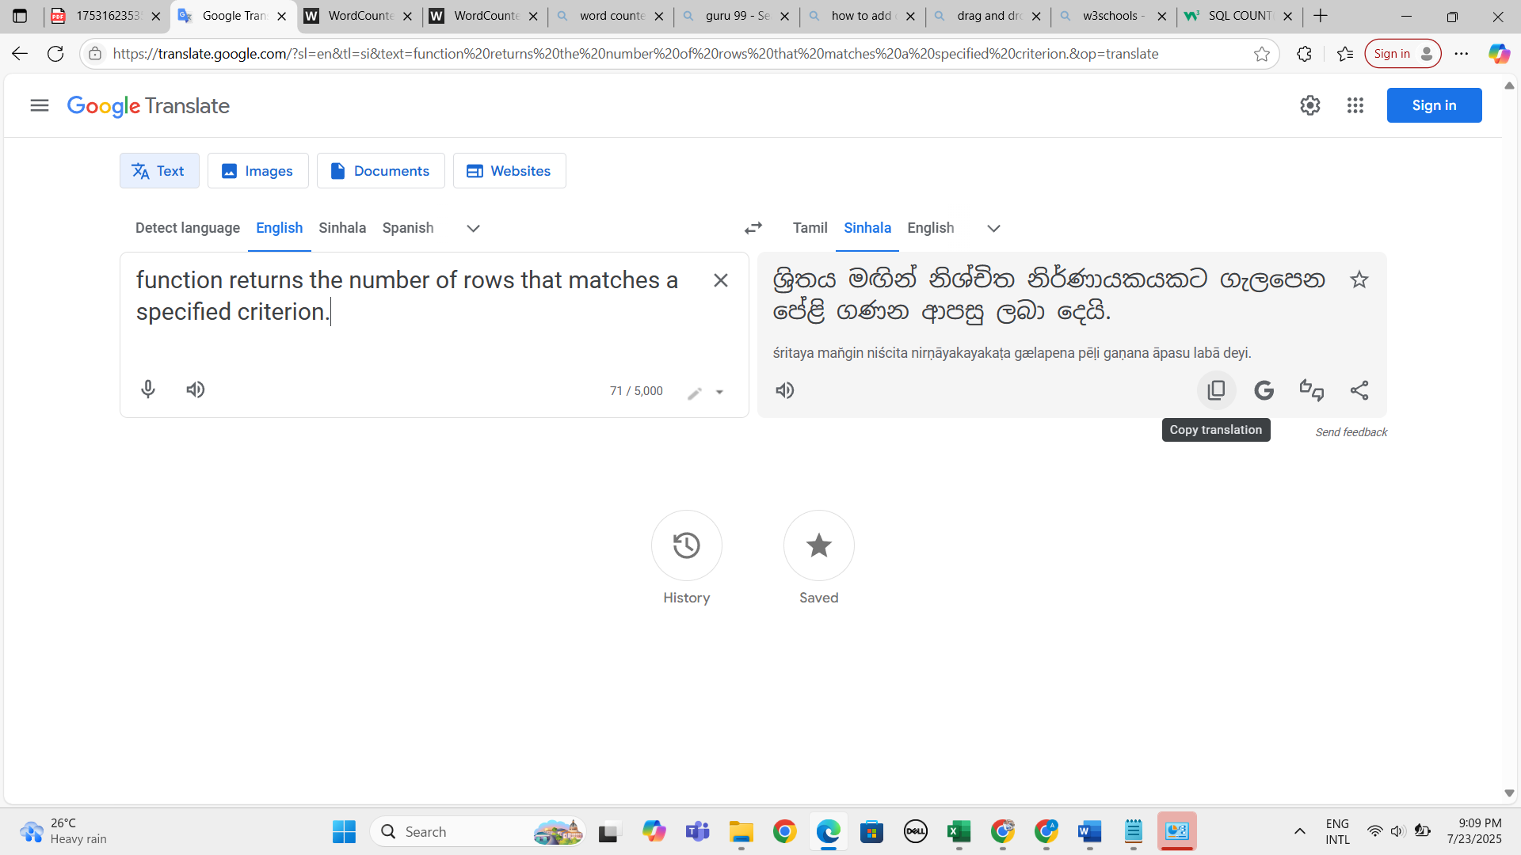 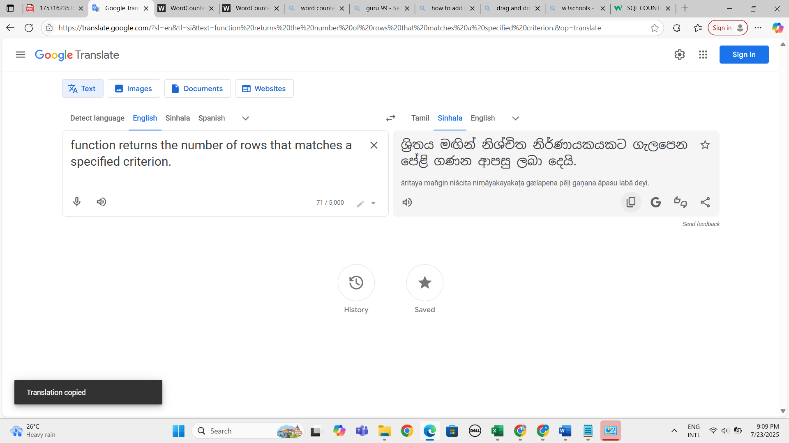
10. Verify whether user can enter more than 5000 characters to check the translation functionality 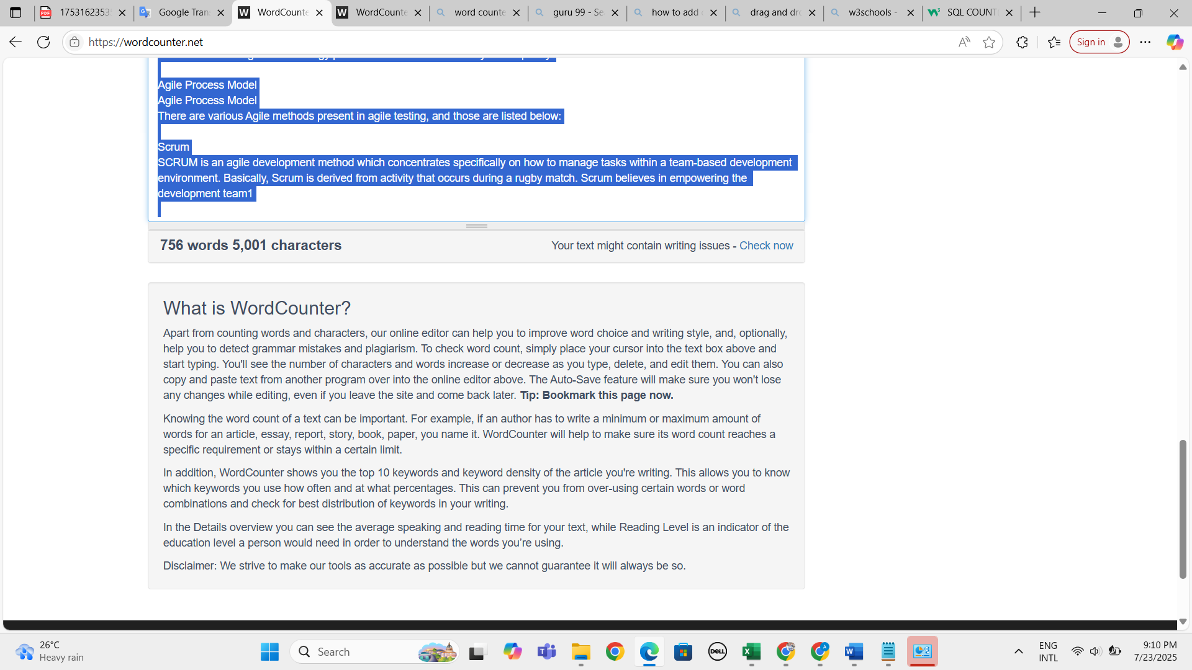 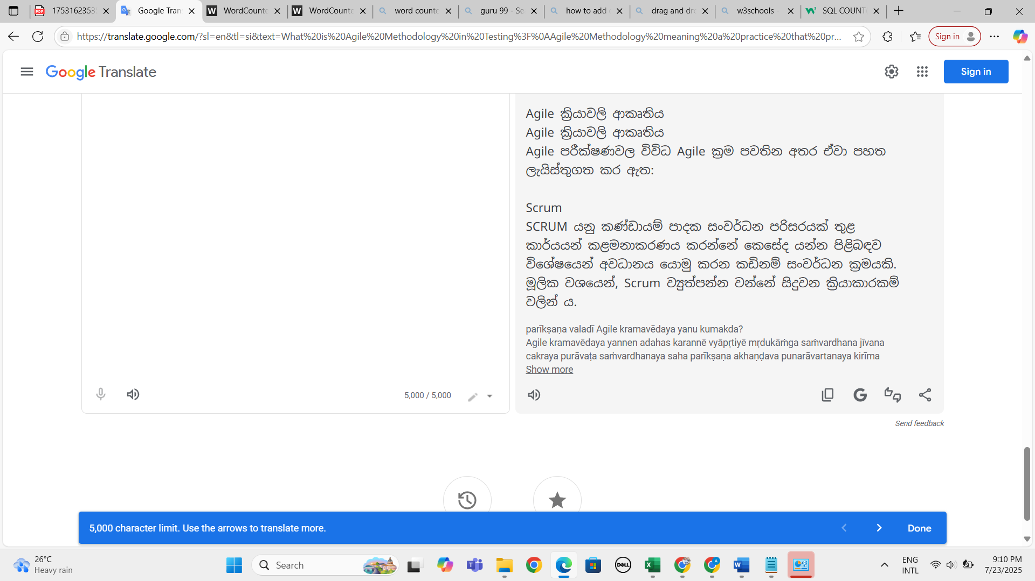
11. Verify whether user can enter sentences to check the translation functionality 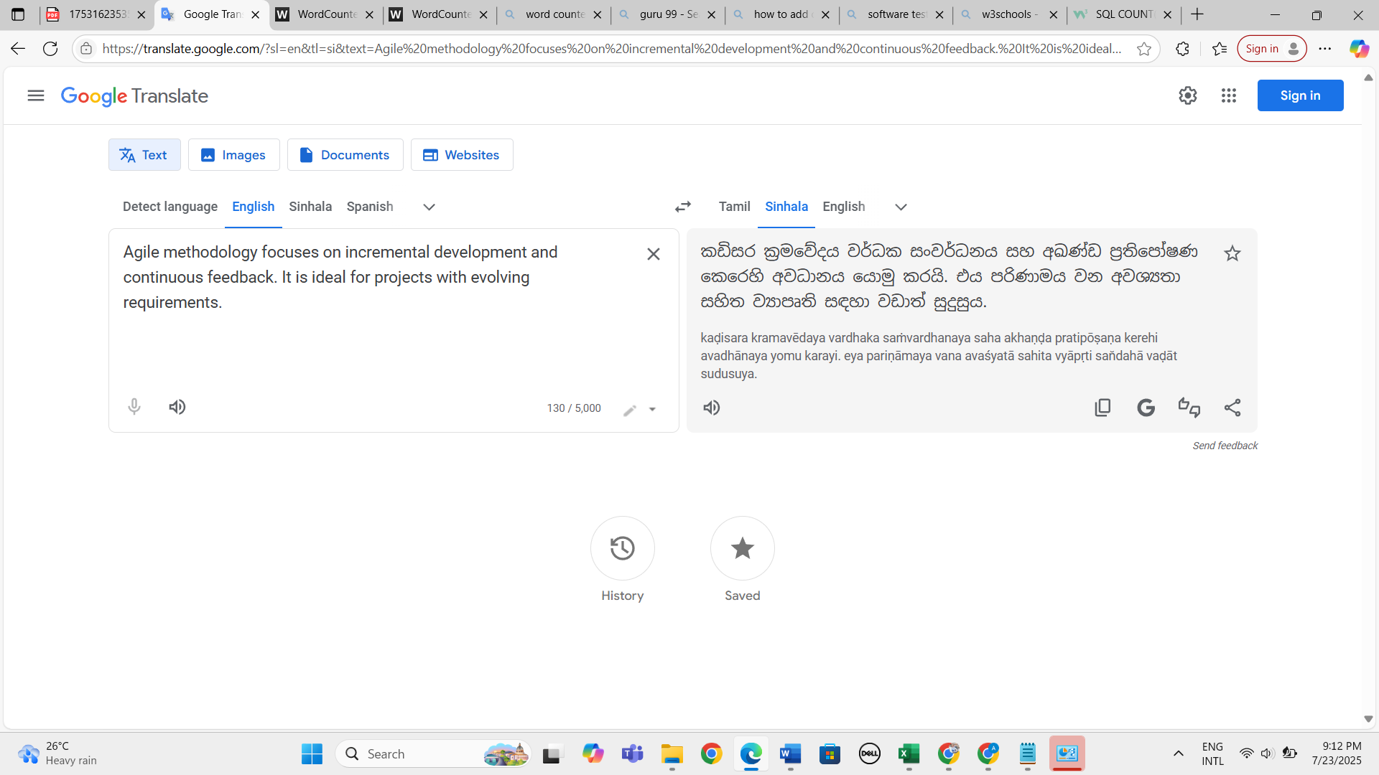
12. Verify whether user can enter paragraphs to check the translation functionality 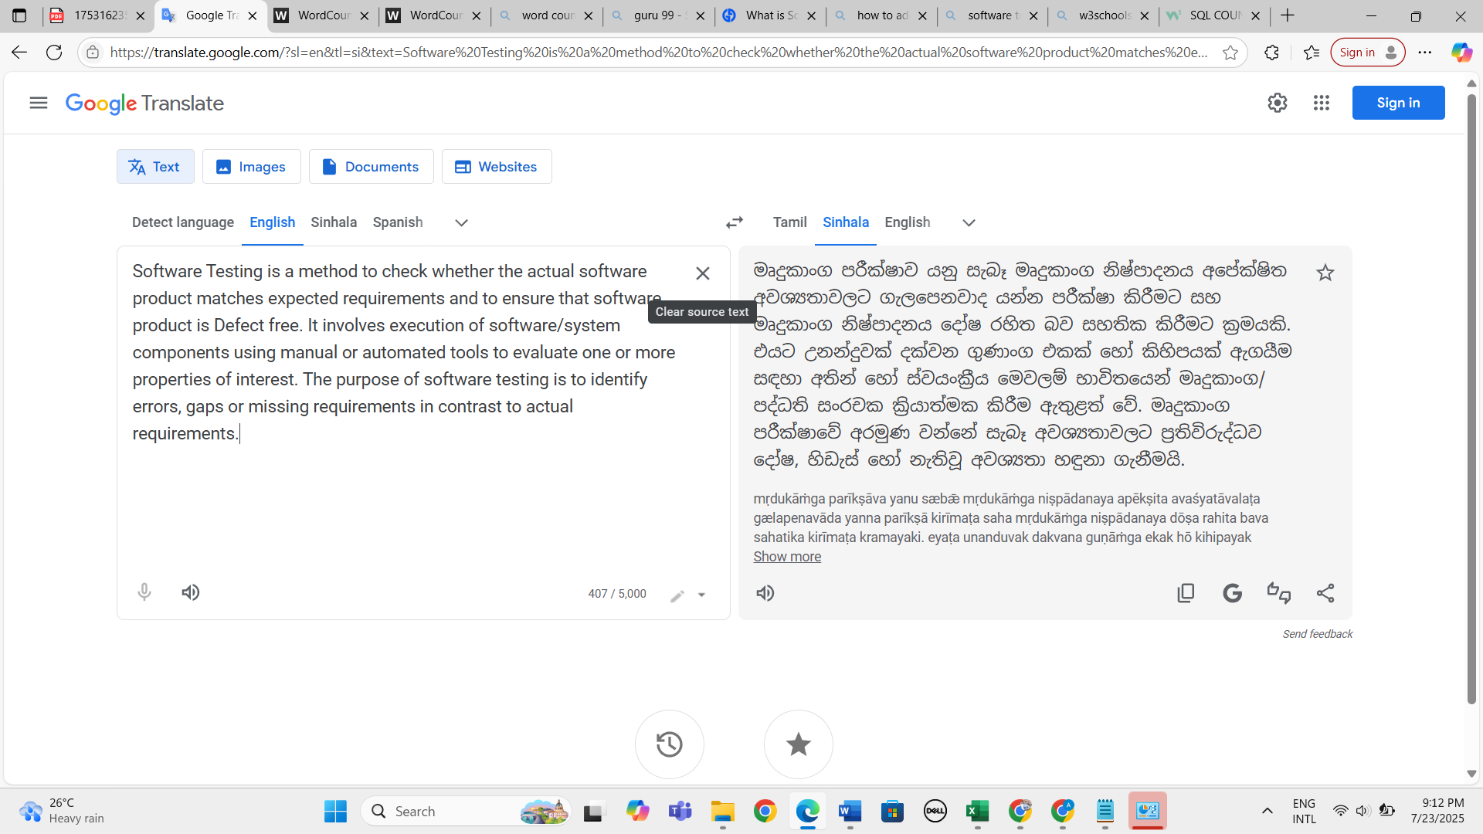
13. Verify whether user can enter numbers to check the translation functionality 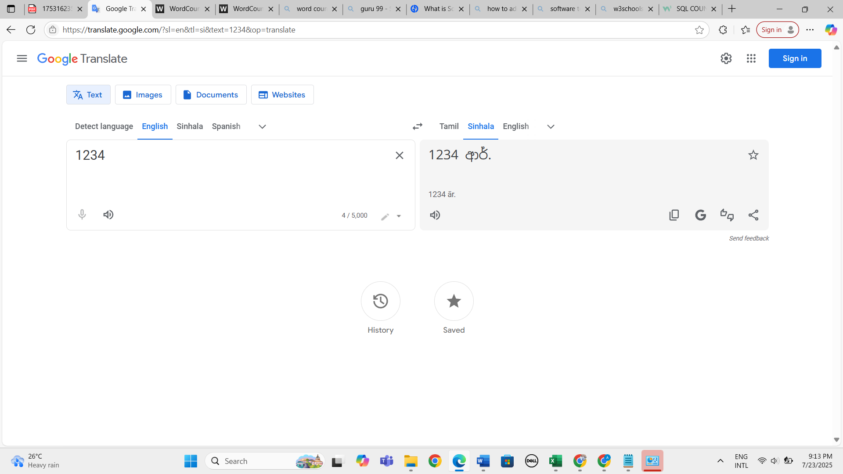
14. Verify whether user can enter special characters to check the translation functionality 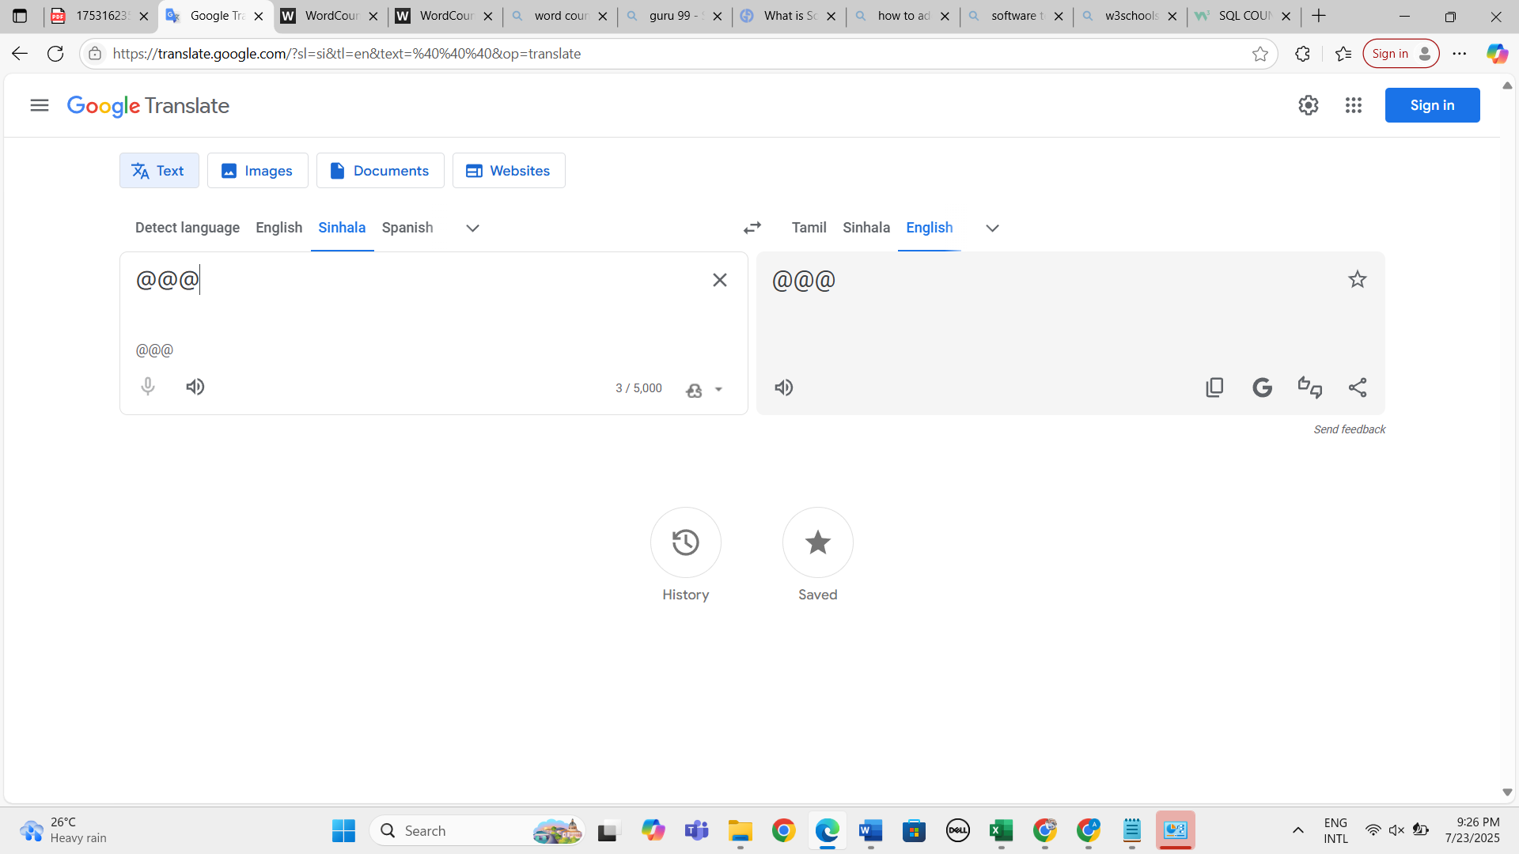
15. Verify whether user can swap the input and output results by clicking upon swap icon 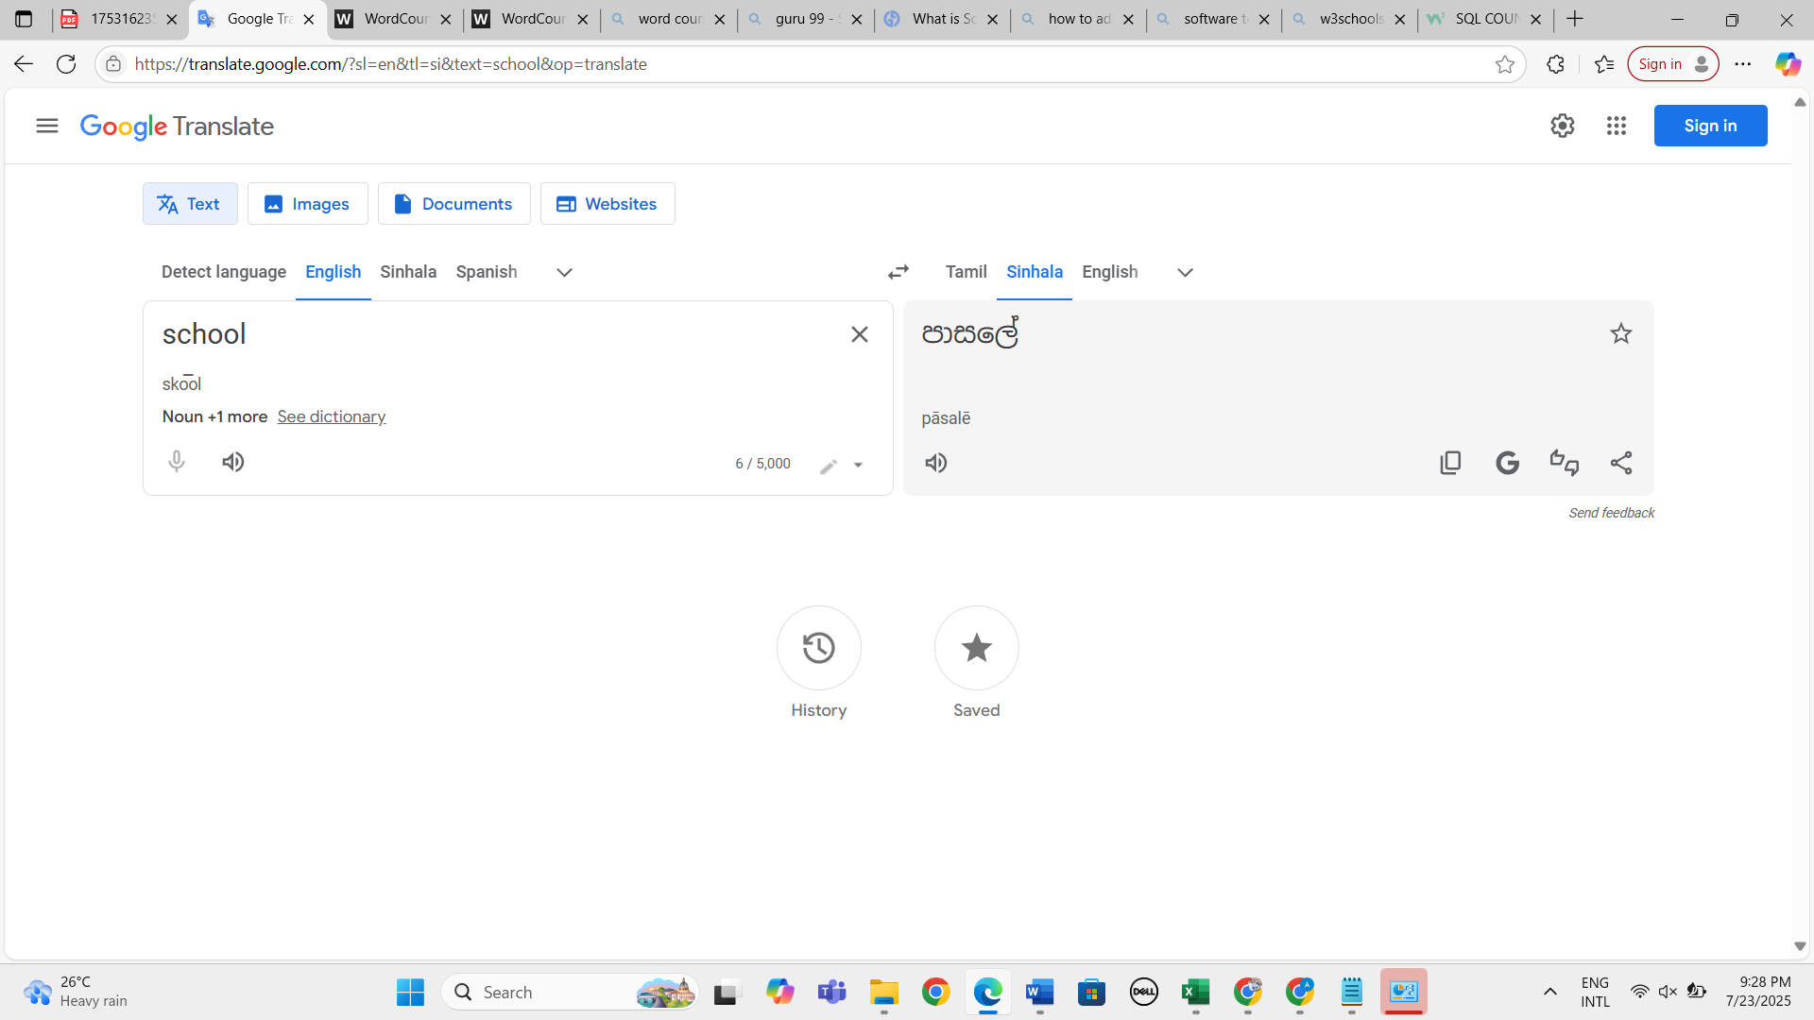 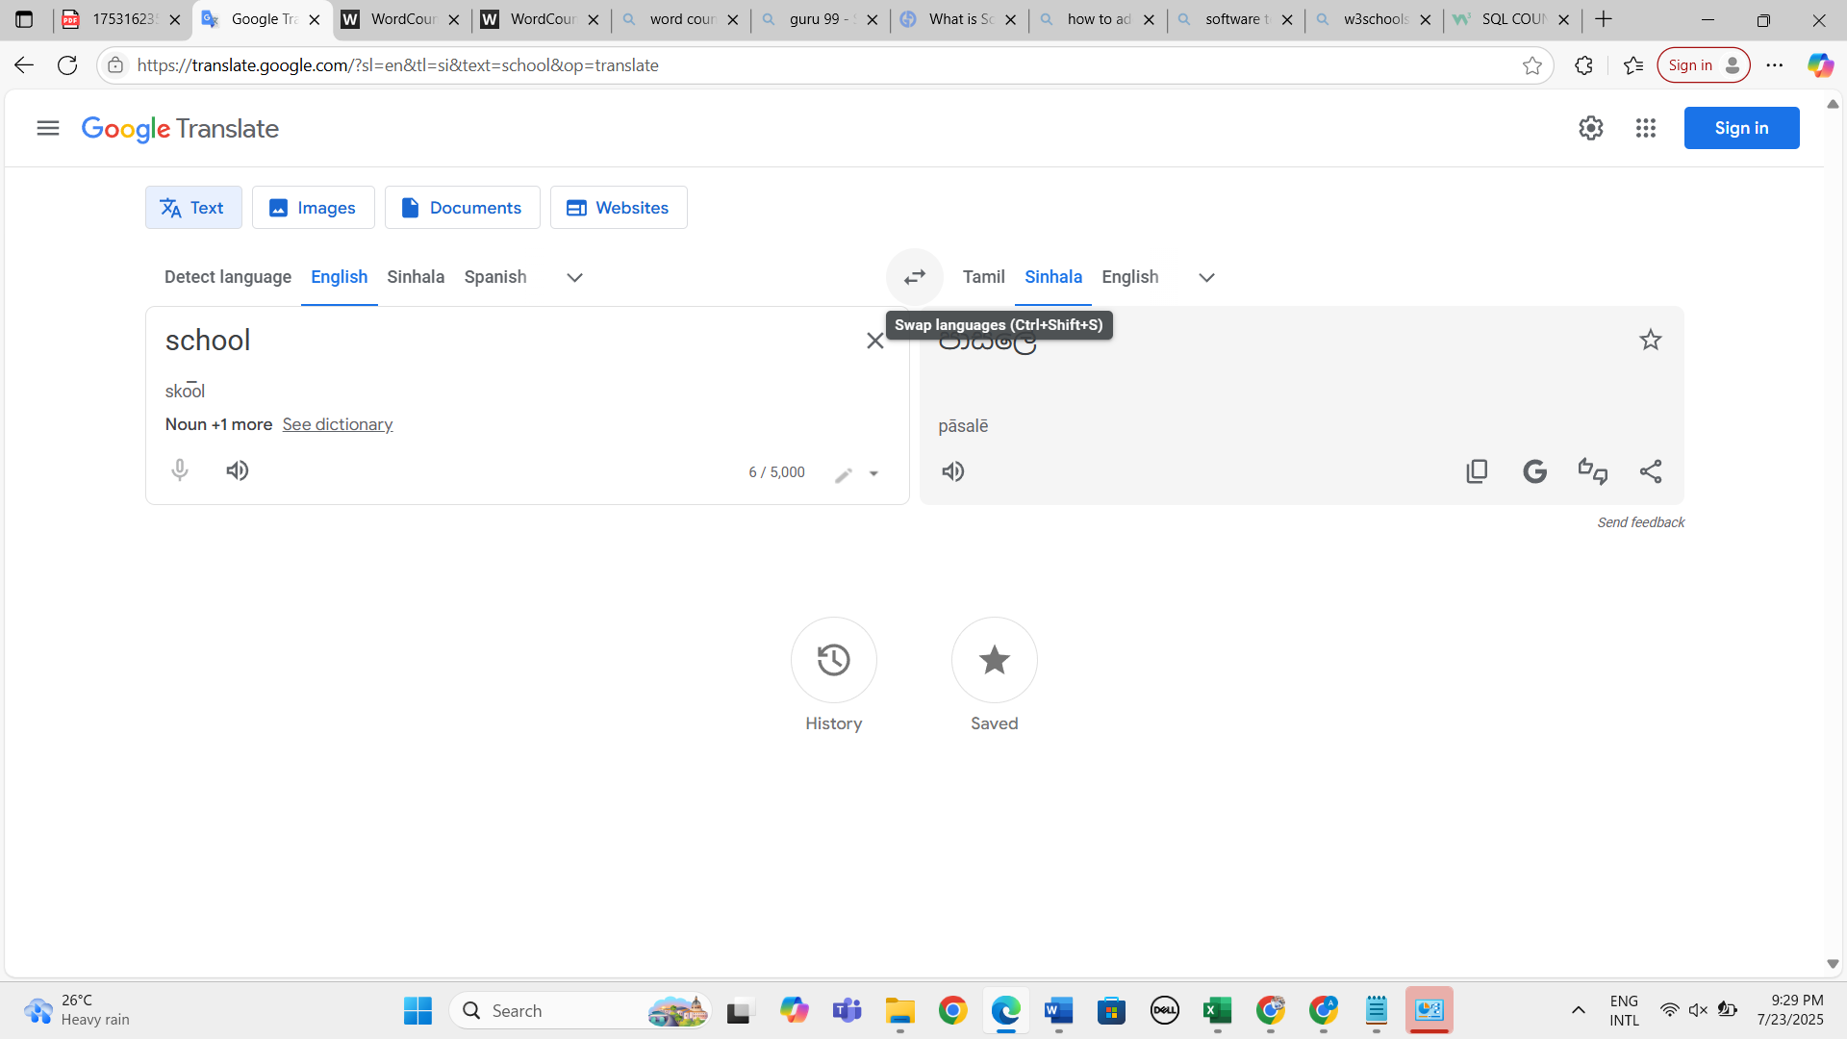 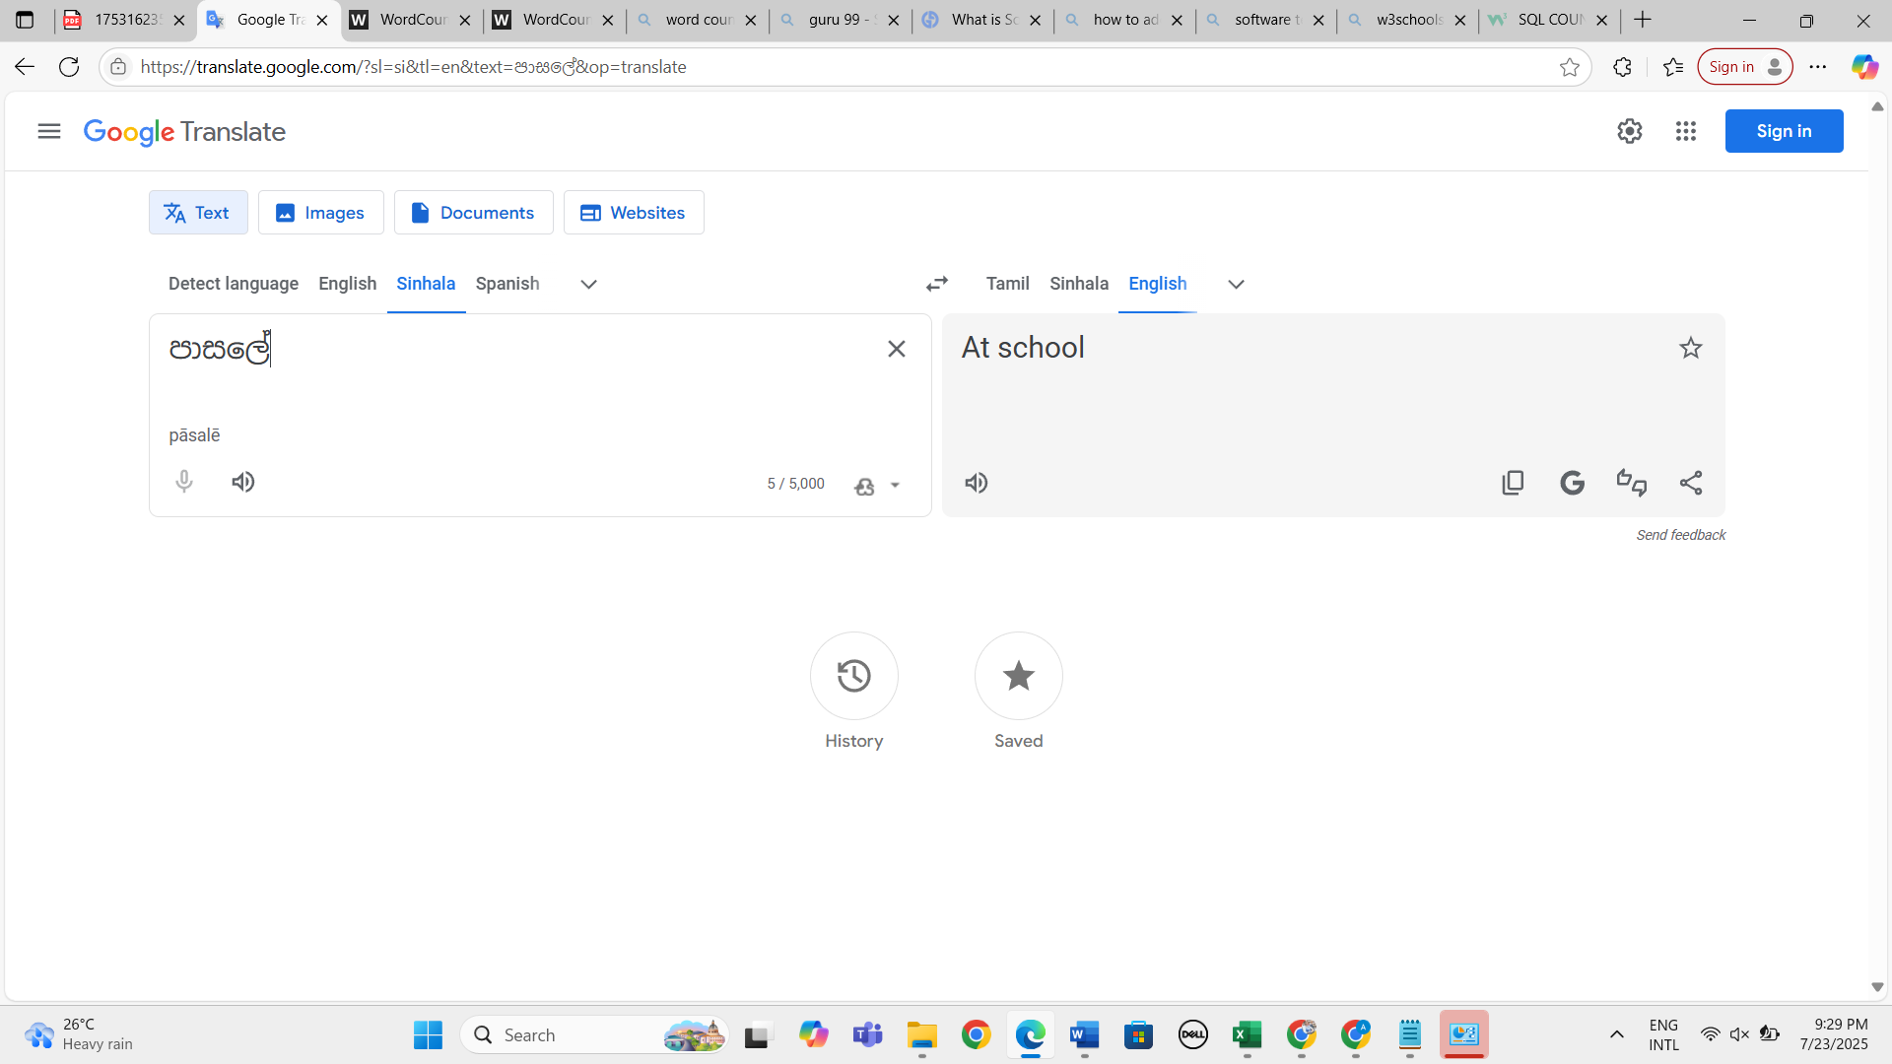
16. Verify whether swap functionality result based on the selected languages 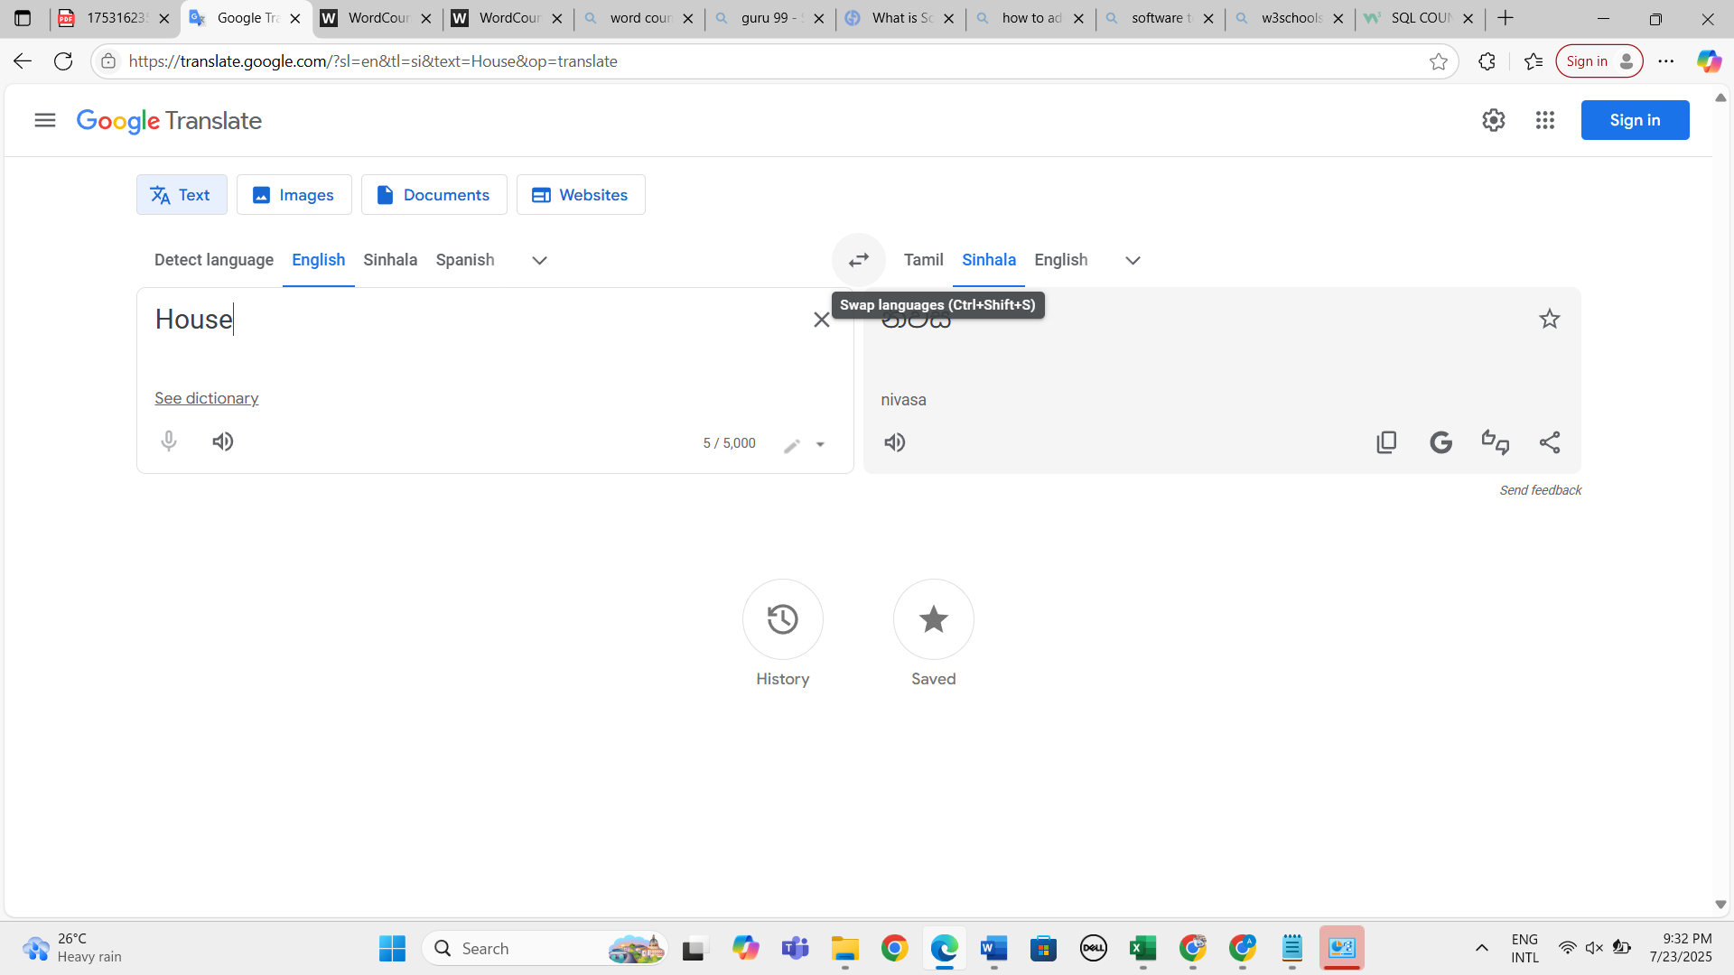 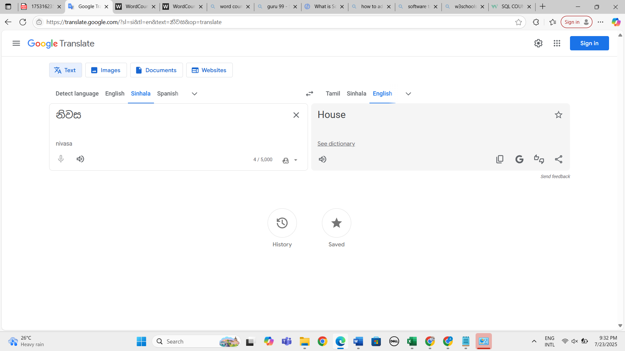
17. Verify whether user can enter texts by clicking upon keyboard icon 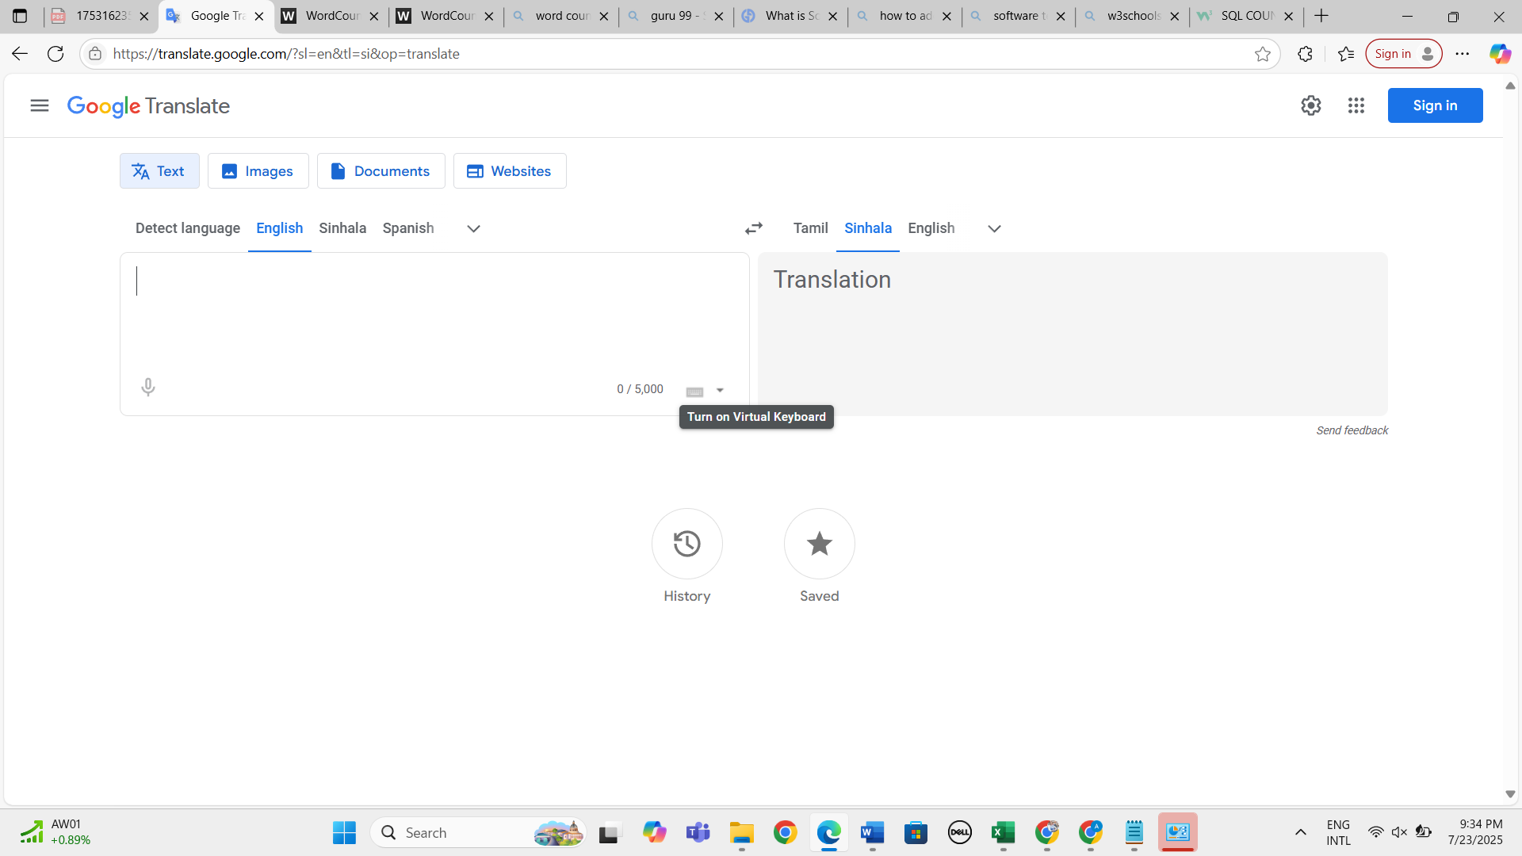 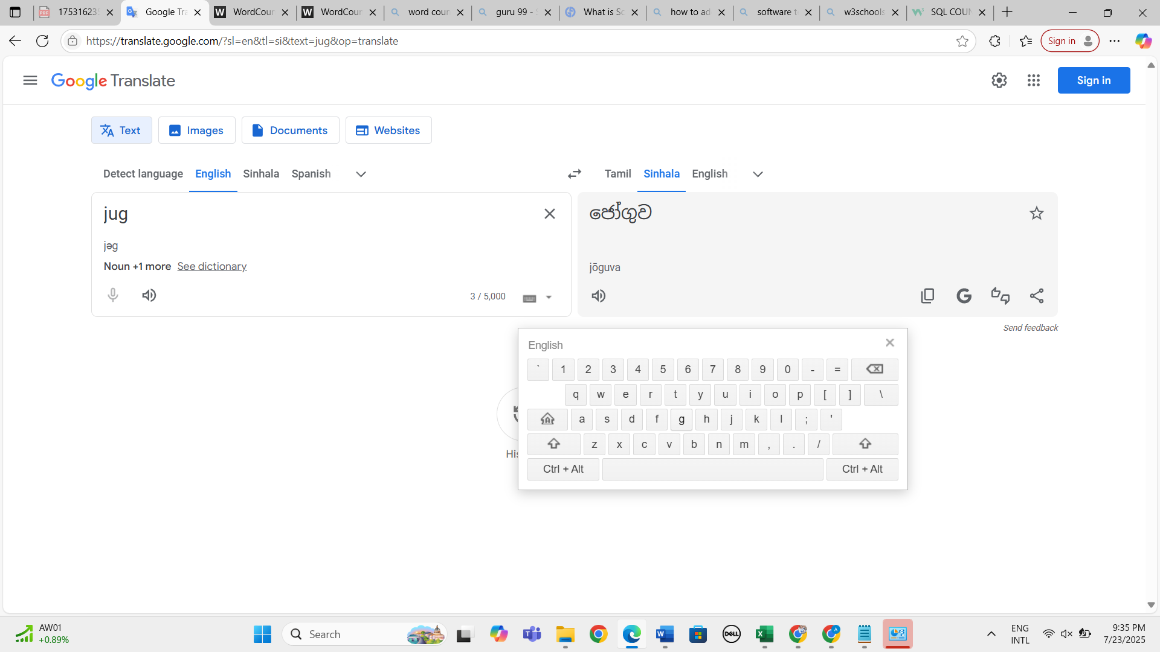
18. Verify whether entered text is correctly translated based on the selected language 
19. Verify whether user can select input tool by clicking upon the dropdown in left side tile 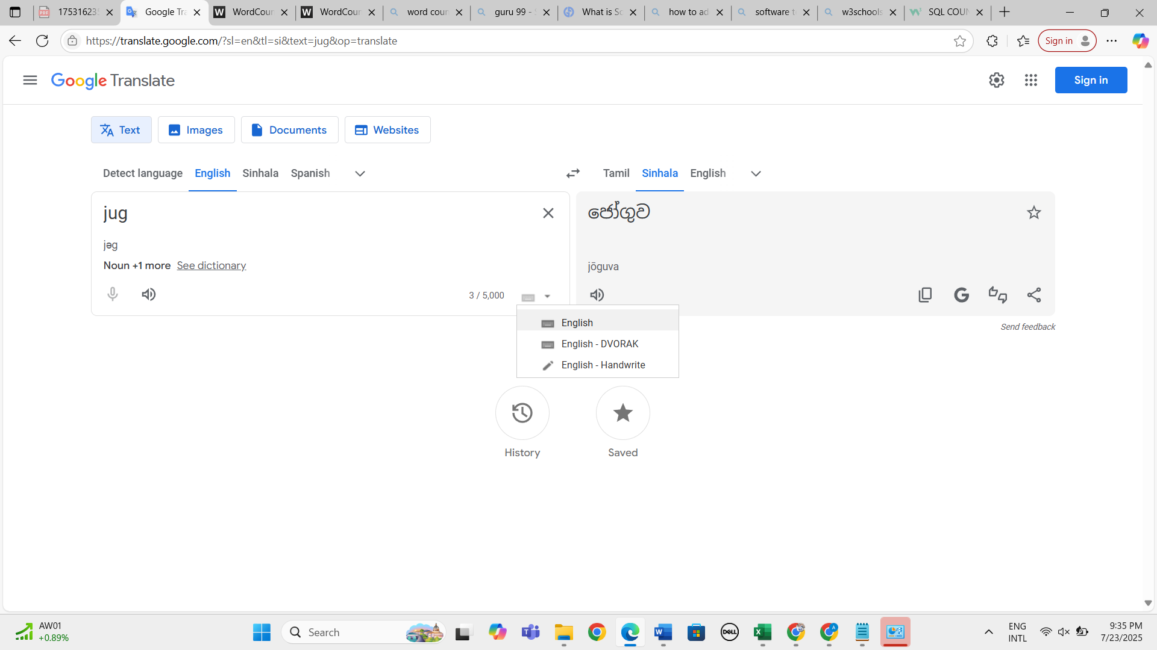
20. Verify whether user can user hand writing option to perform translation functionality 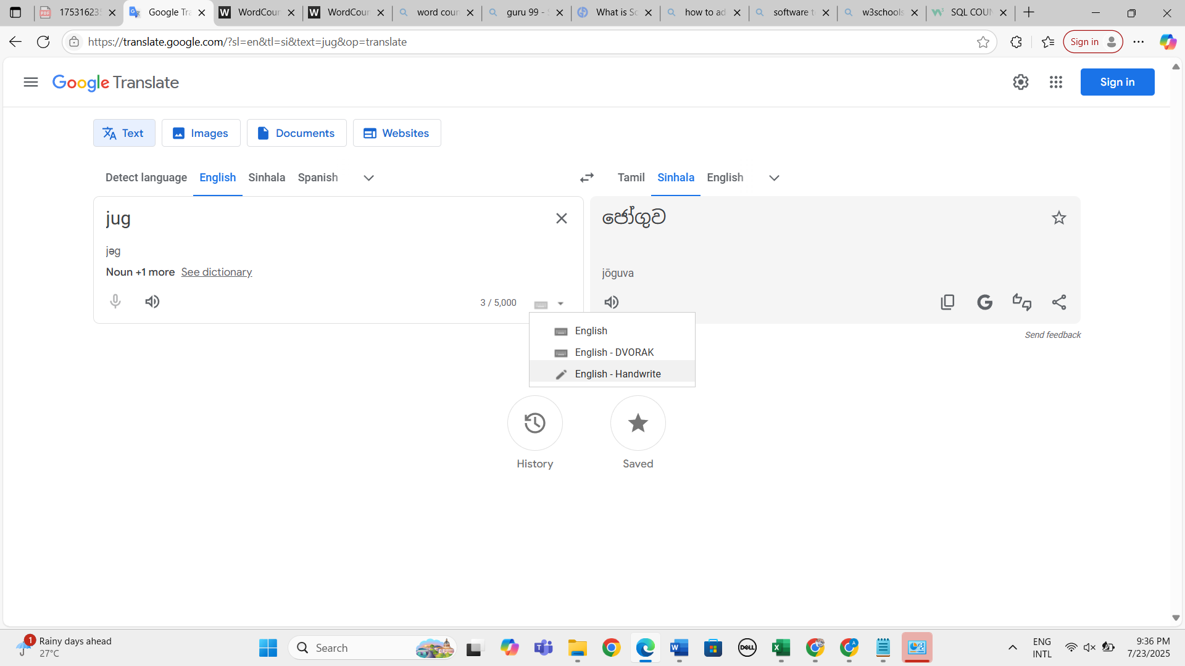 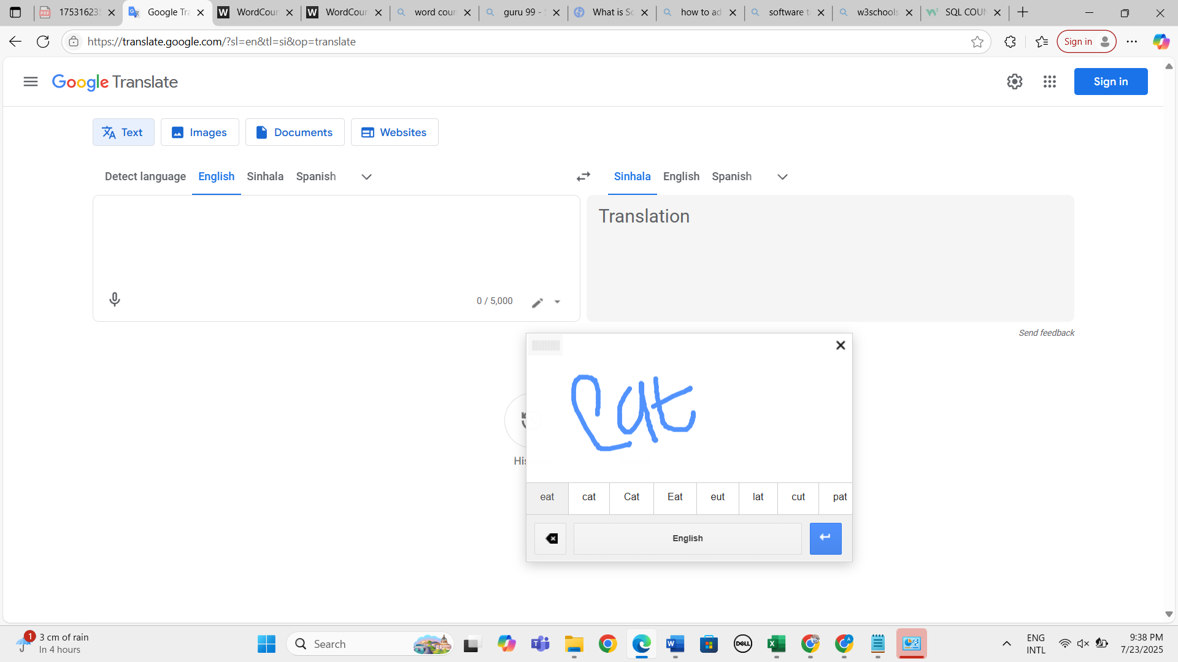 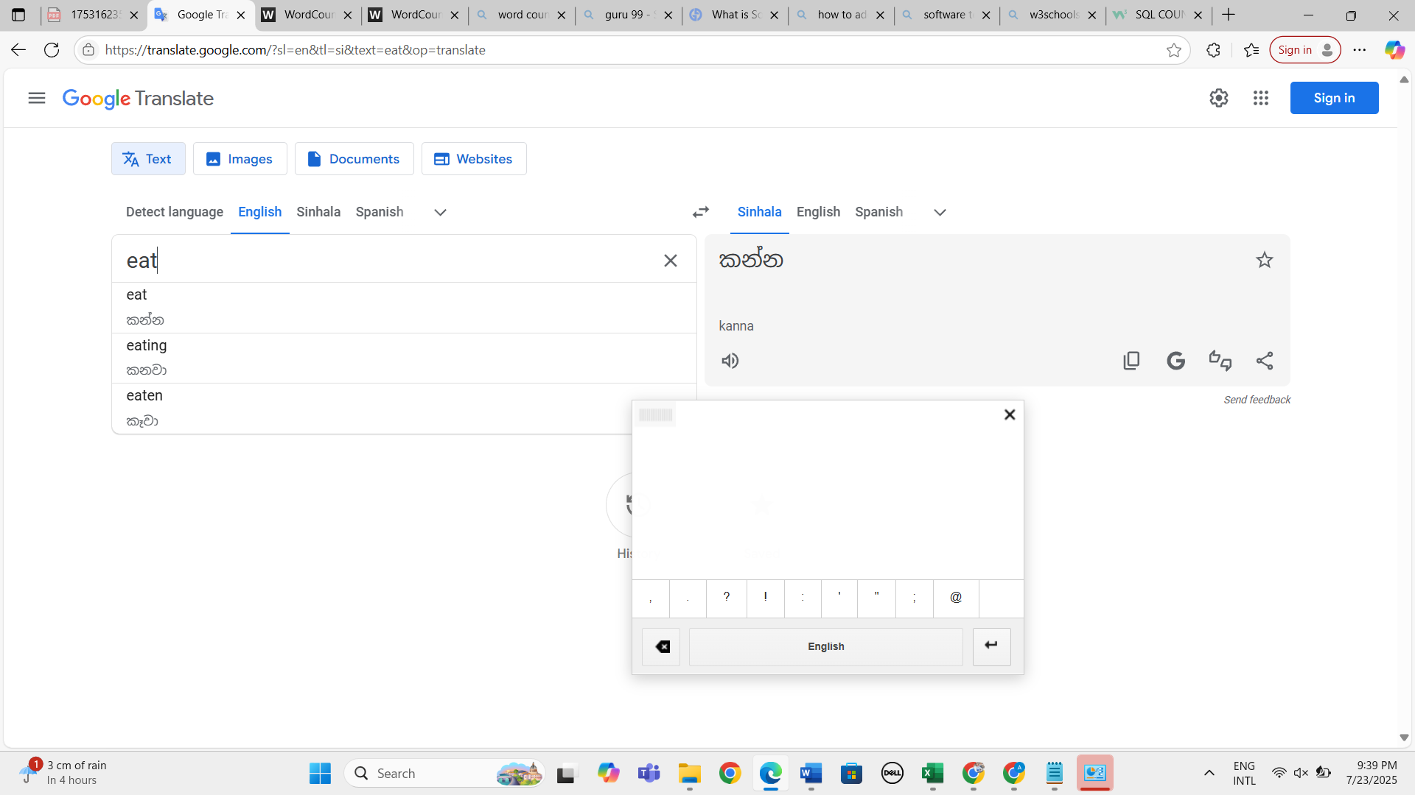
21. Verify whether user can enter text to check the translation functionality via keyboard by selecting "DVORAK" option from the dropdown 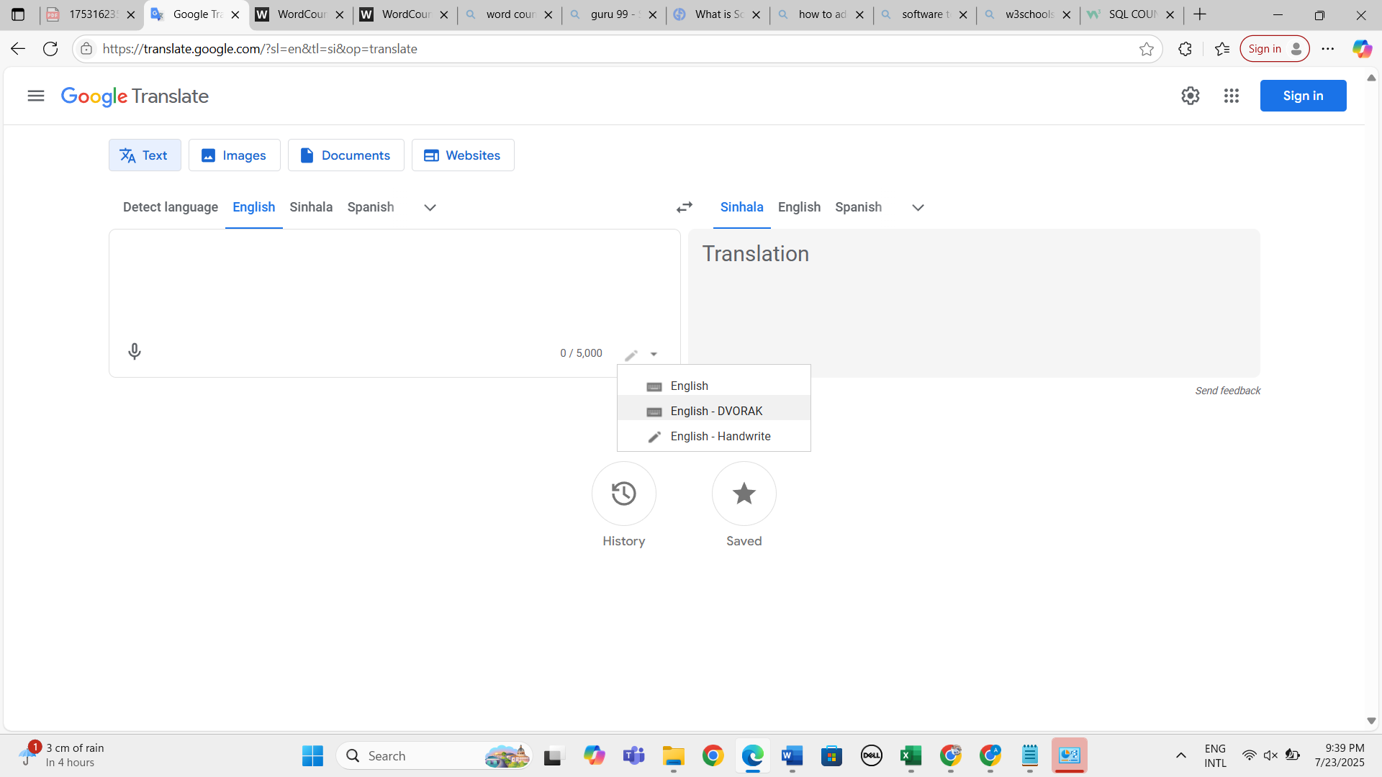v 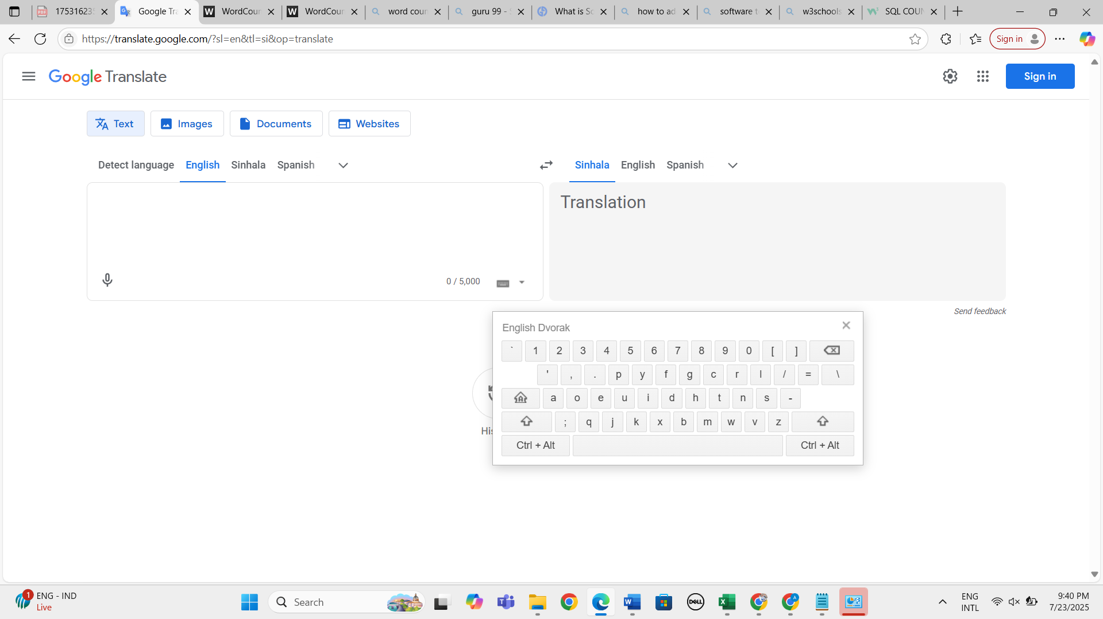 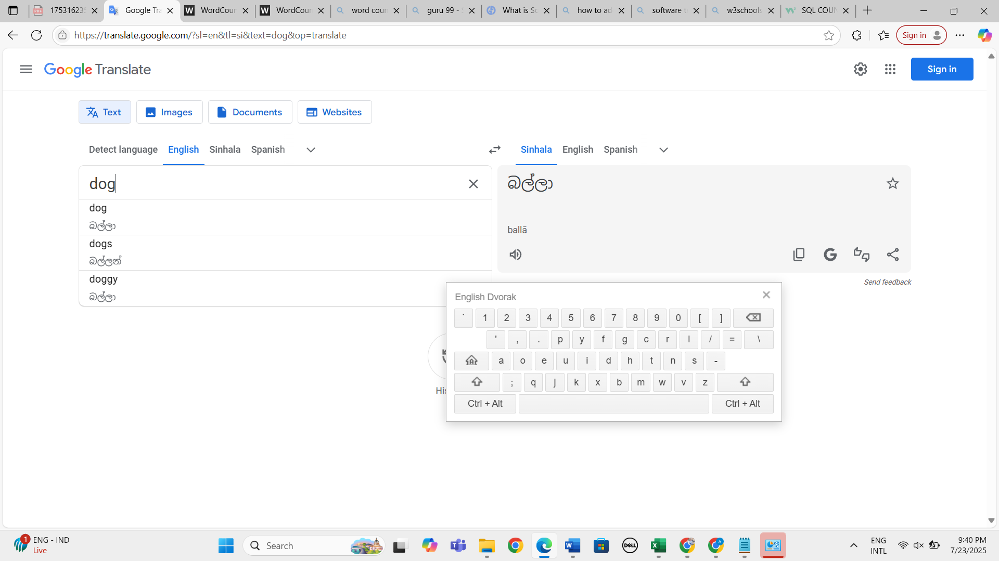
22. Verify whether user can see the searched history by clicking upon history icon 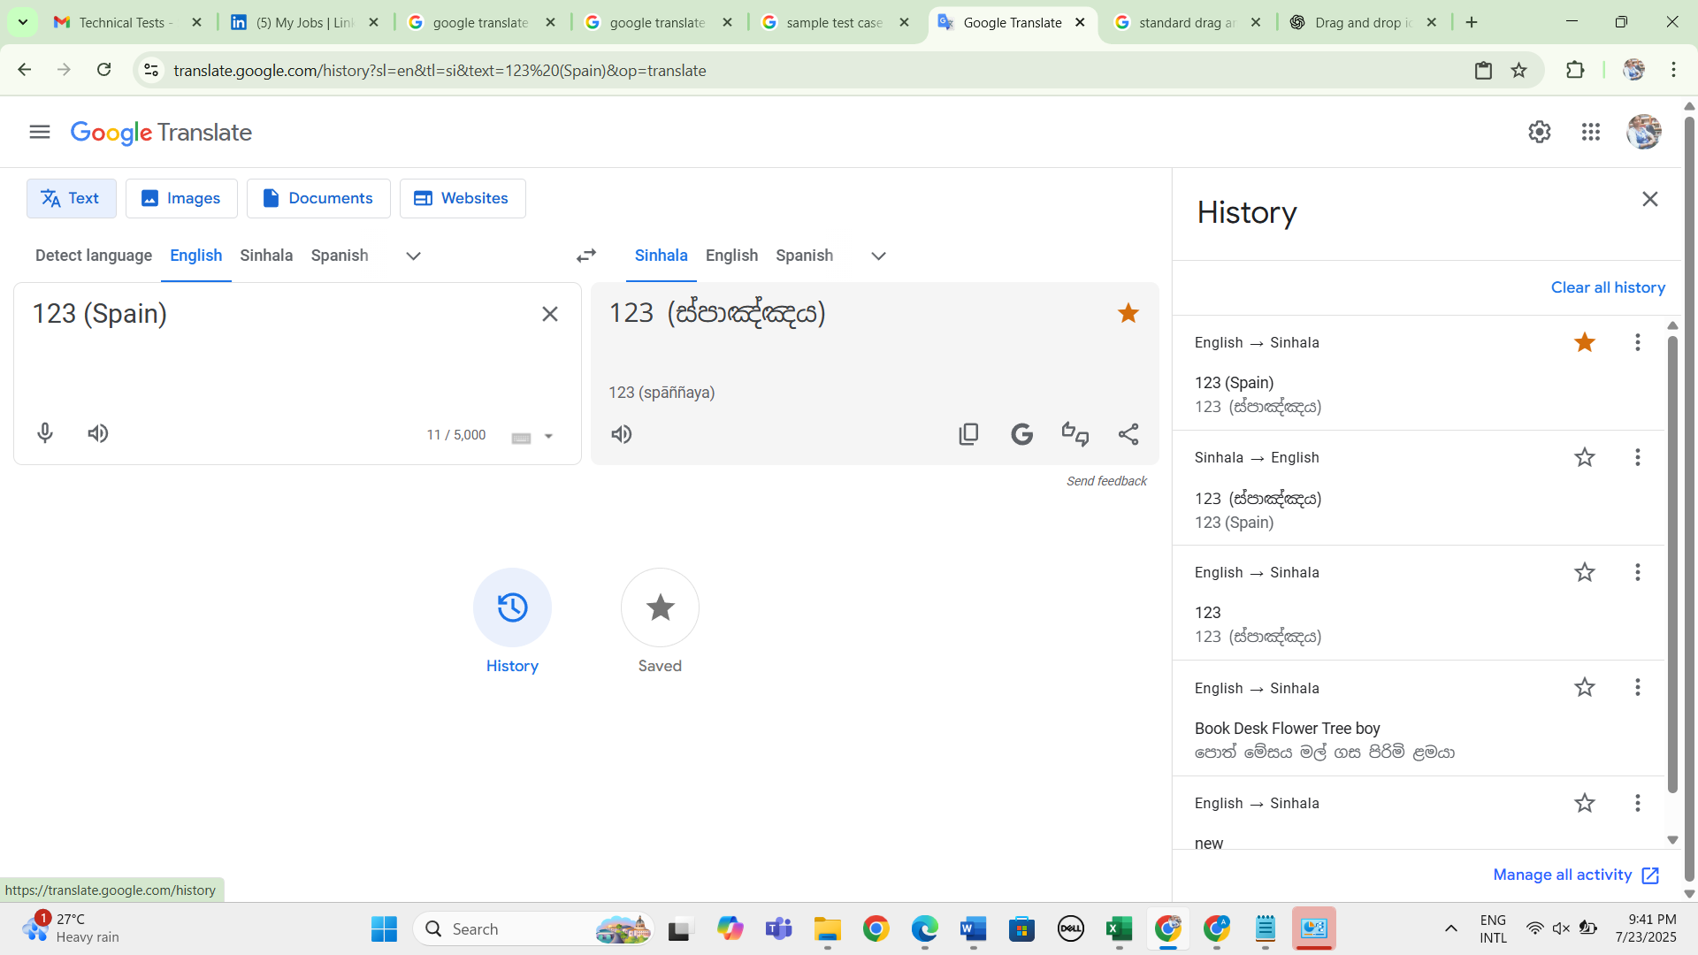
23. Verify whether user can see the saved results by clicking upon save icon 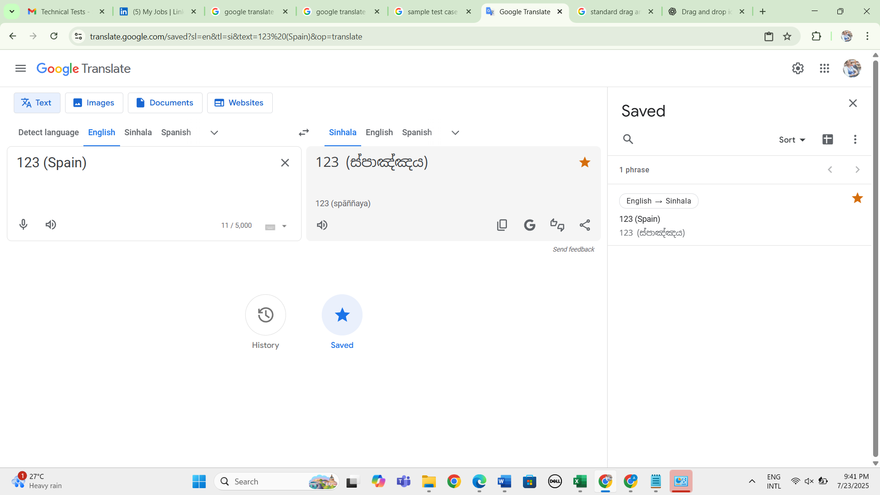
24. Verify whether user can perform search functionality by clicking upon "G" icon based on the given text 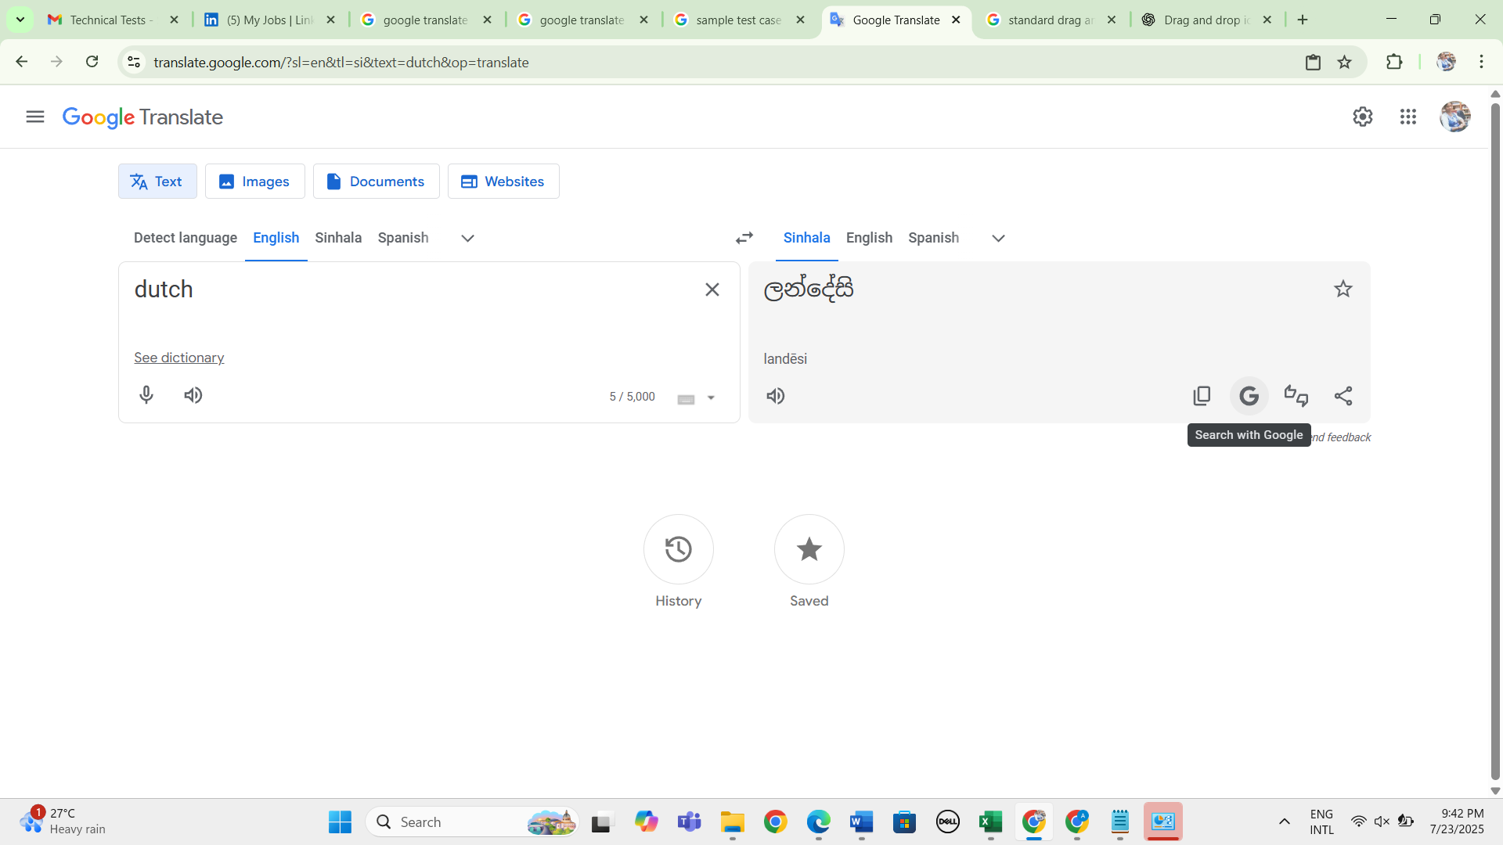 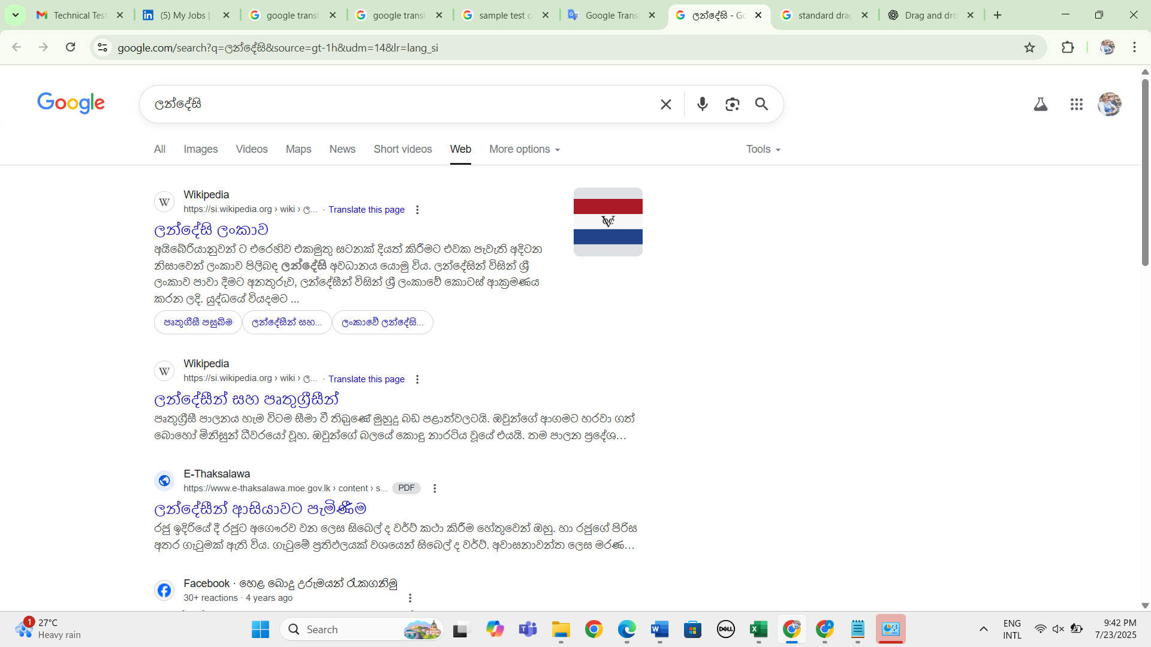
25. Verify whether user can perform share the output result by clicking upon share icon 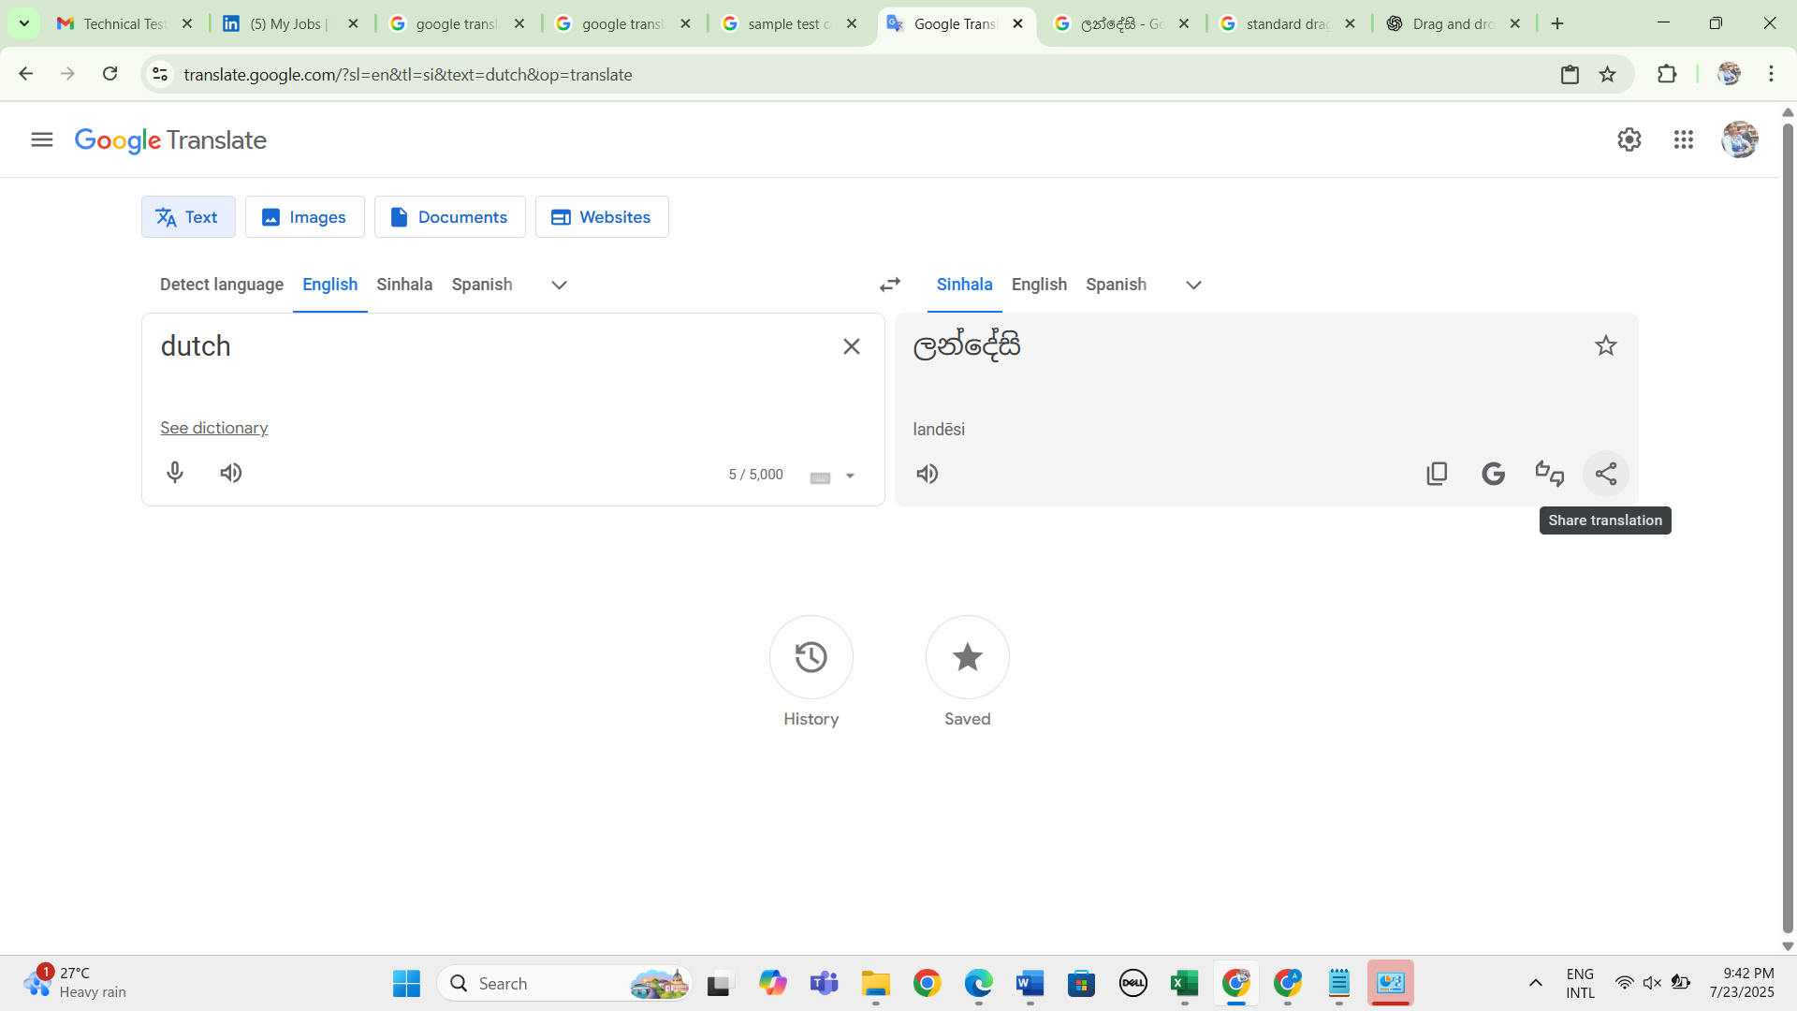 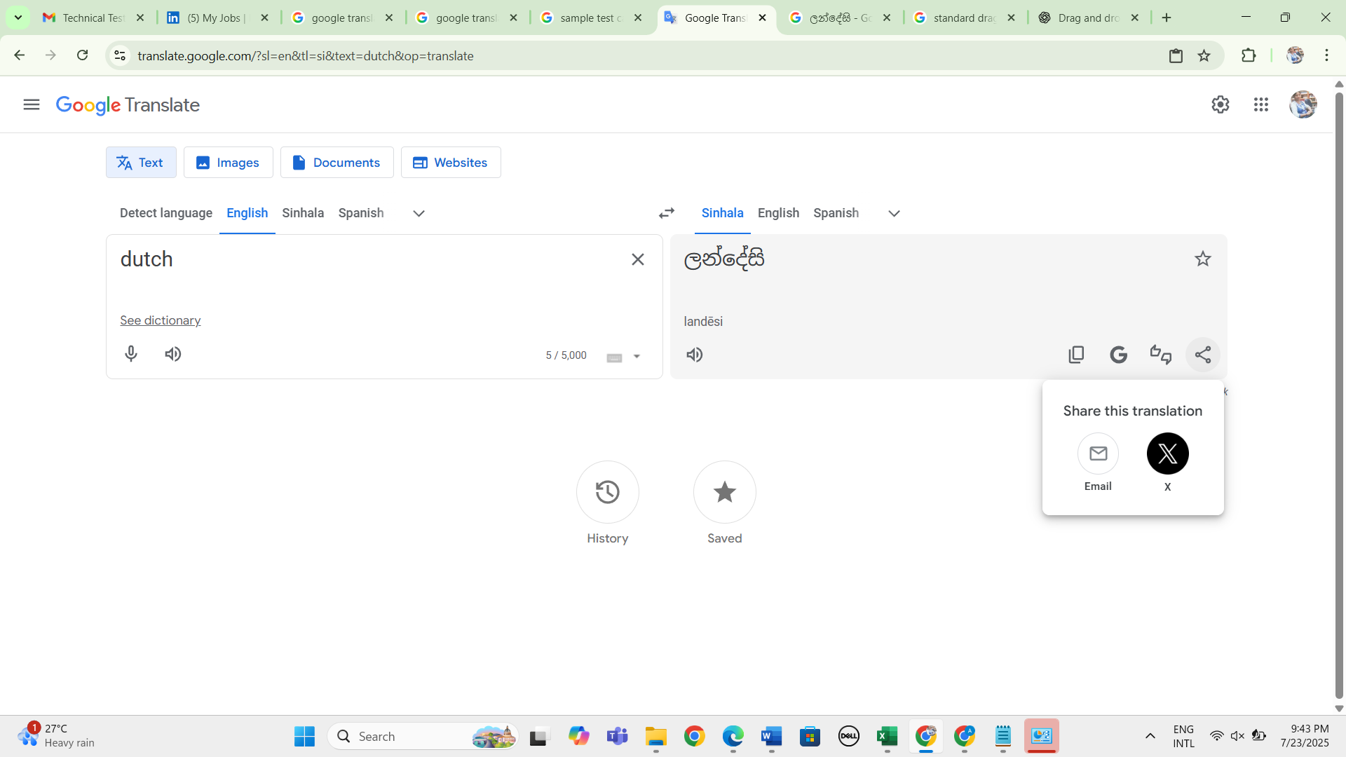
26. Verify whether user can give feedback by clicking upon rate icon 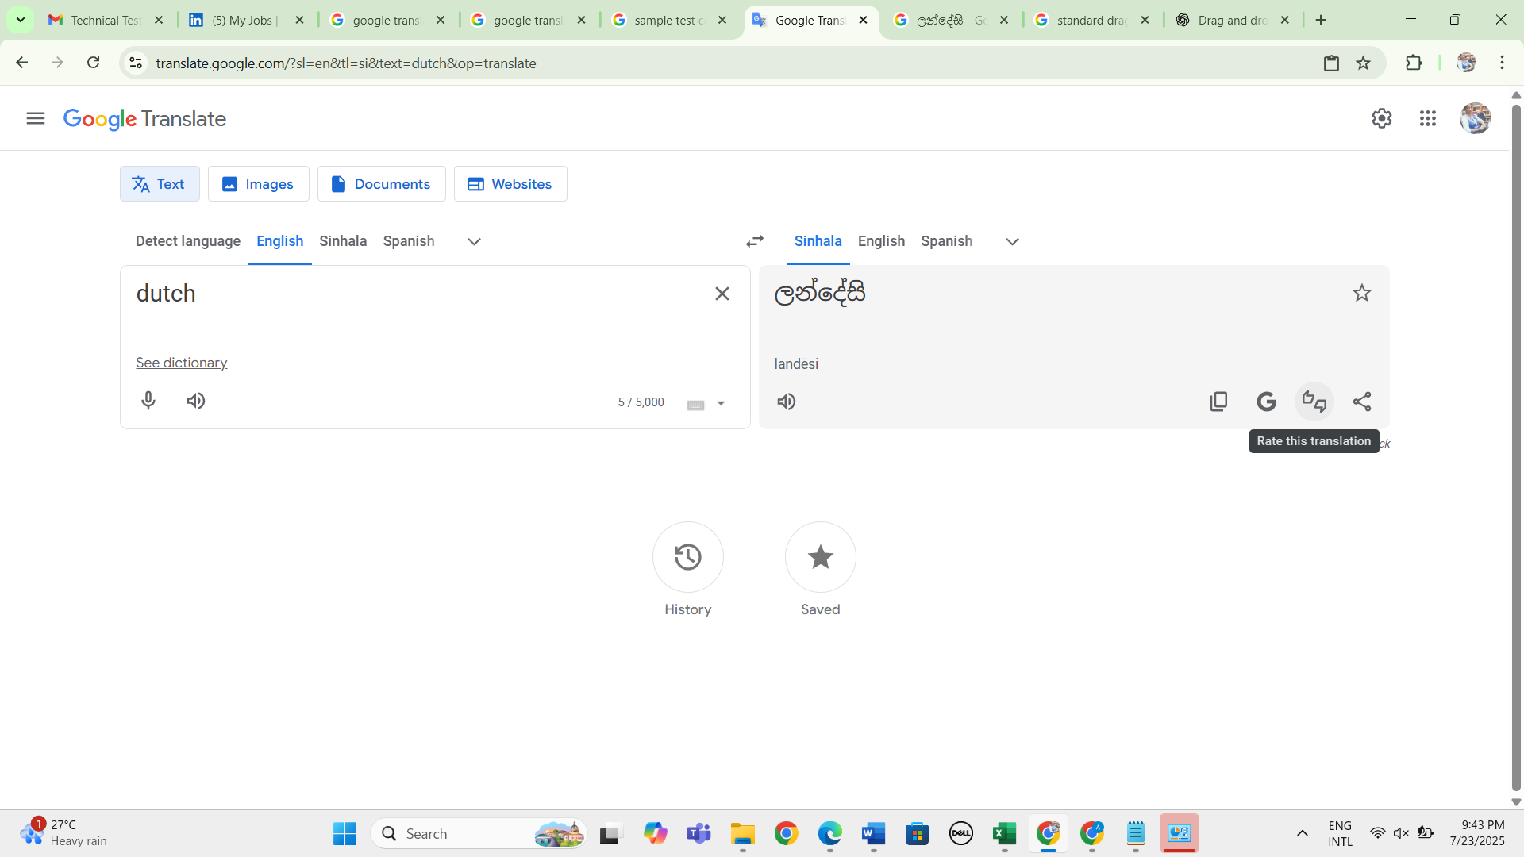 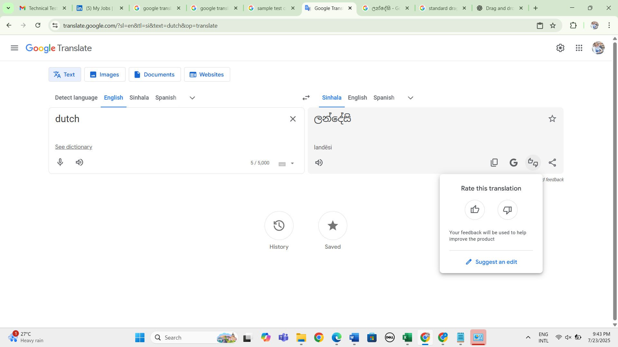
27. Verify whether user can give feedback by clicking upon send feedback link 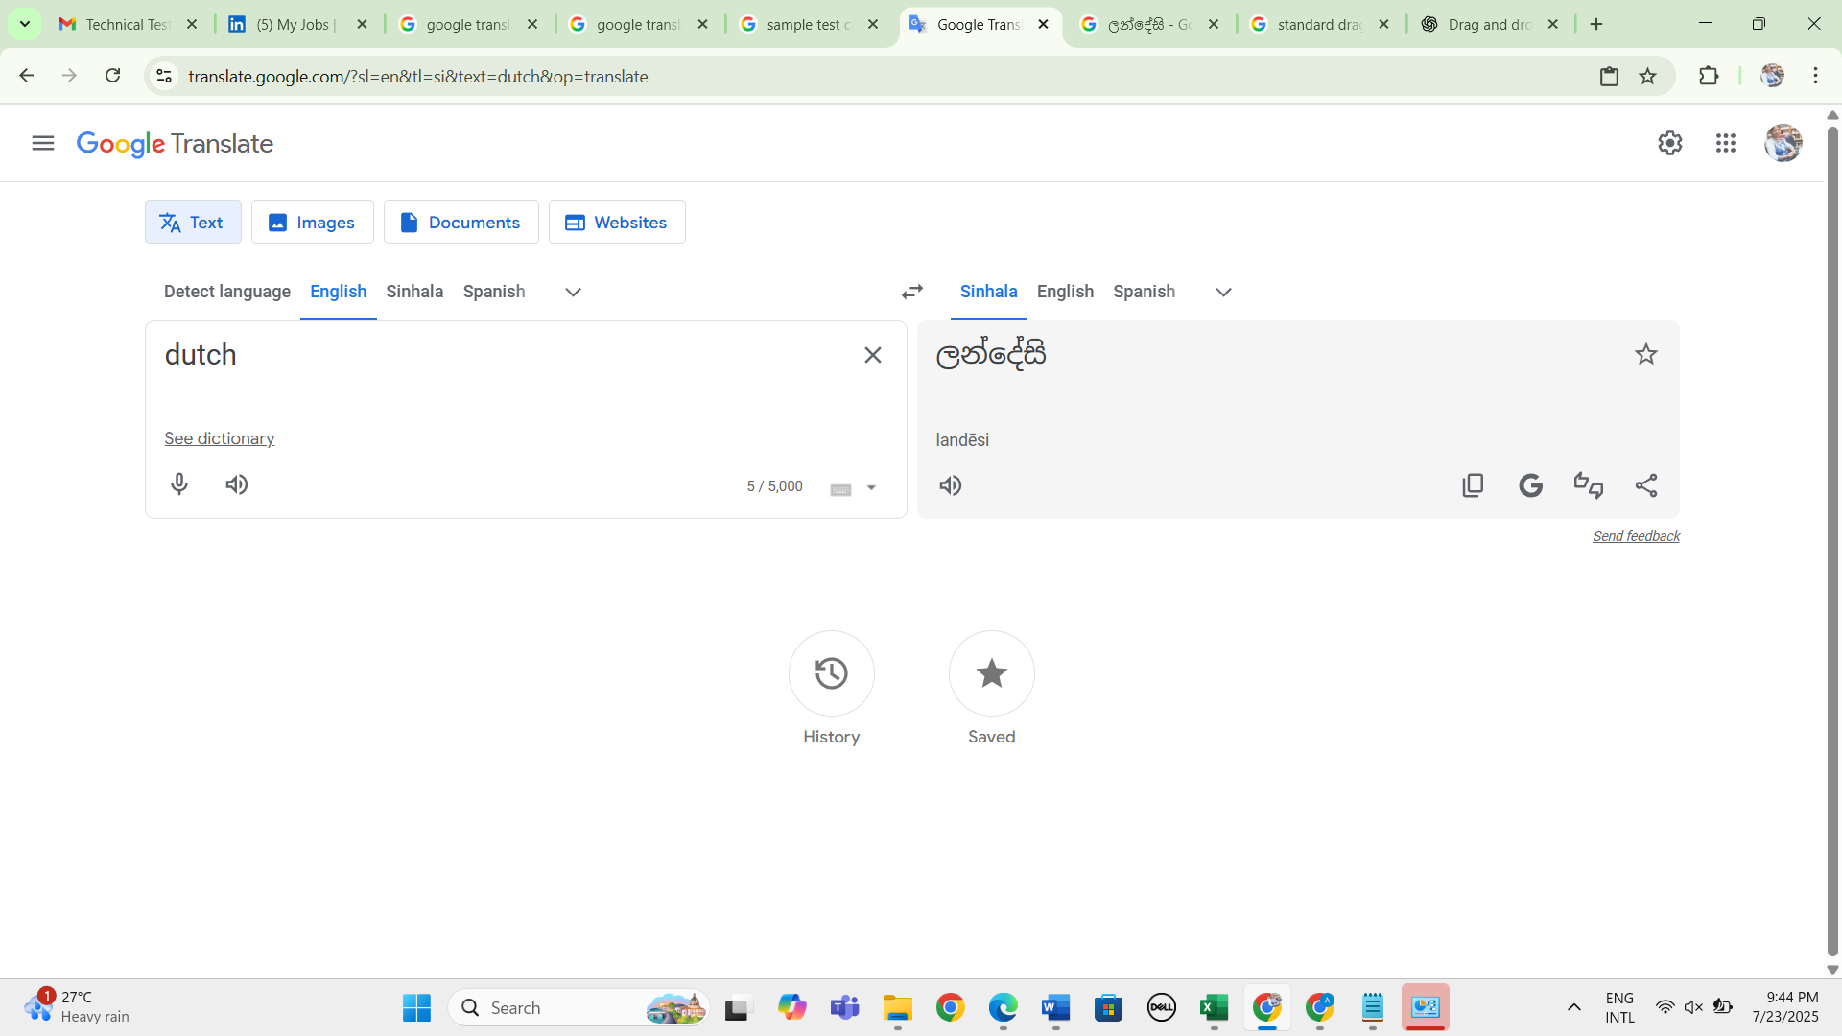 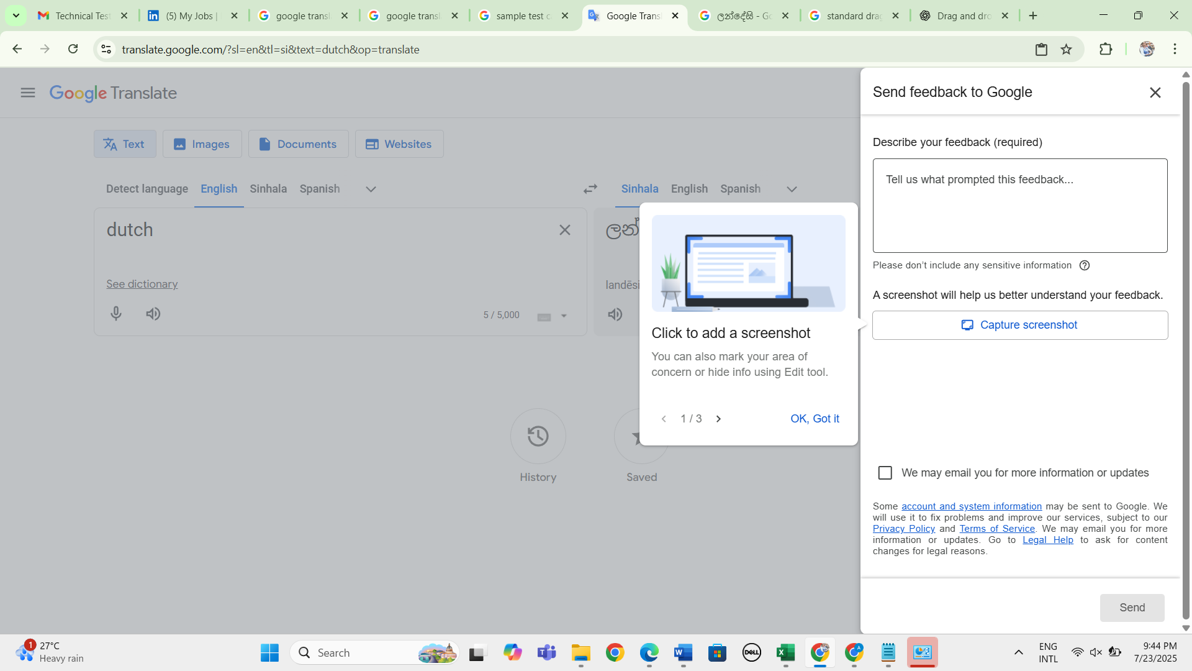
28. Verify whether user can input image to check translation functionality by performing drag and drop functionality clicking upon "cloud icon 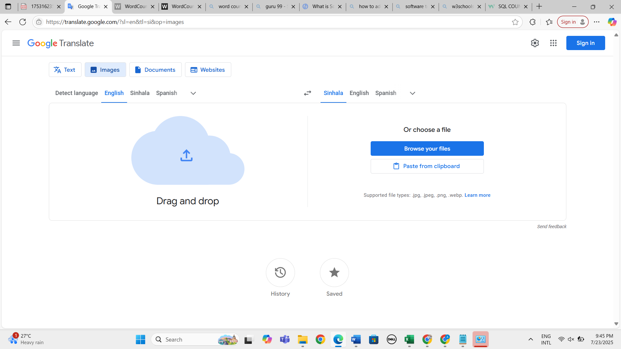 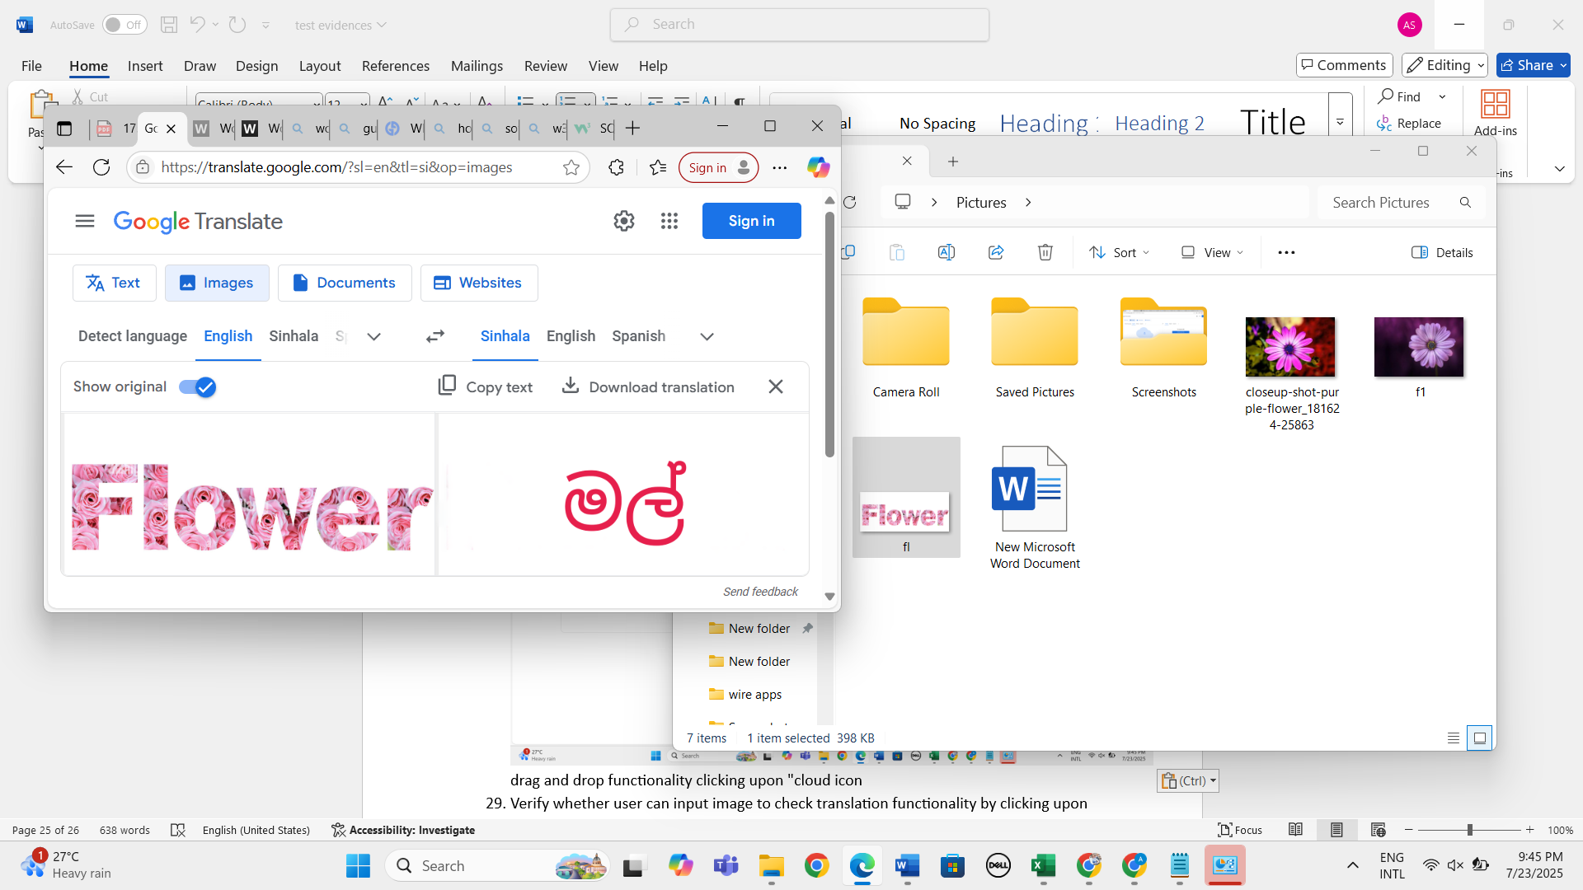
29. Verify whether user can input image to check translation functionality by clicking upon "cloud icon
30. Verify whether user can input image to check translation functionality by clicking upon "browse your files" button 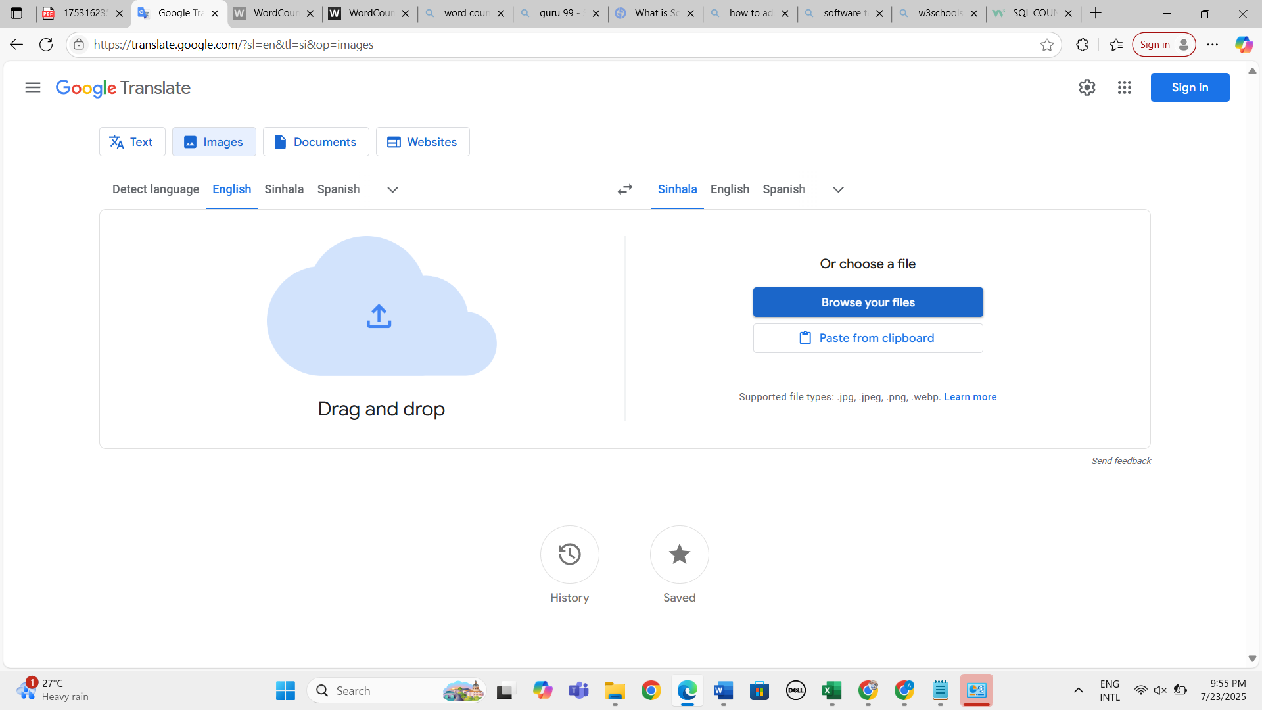 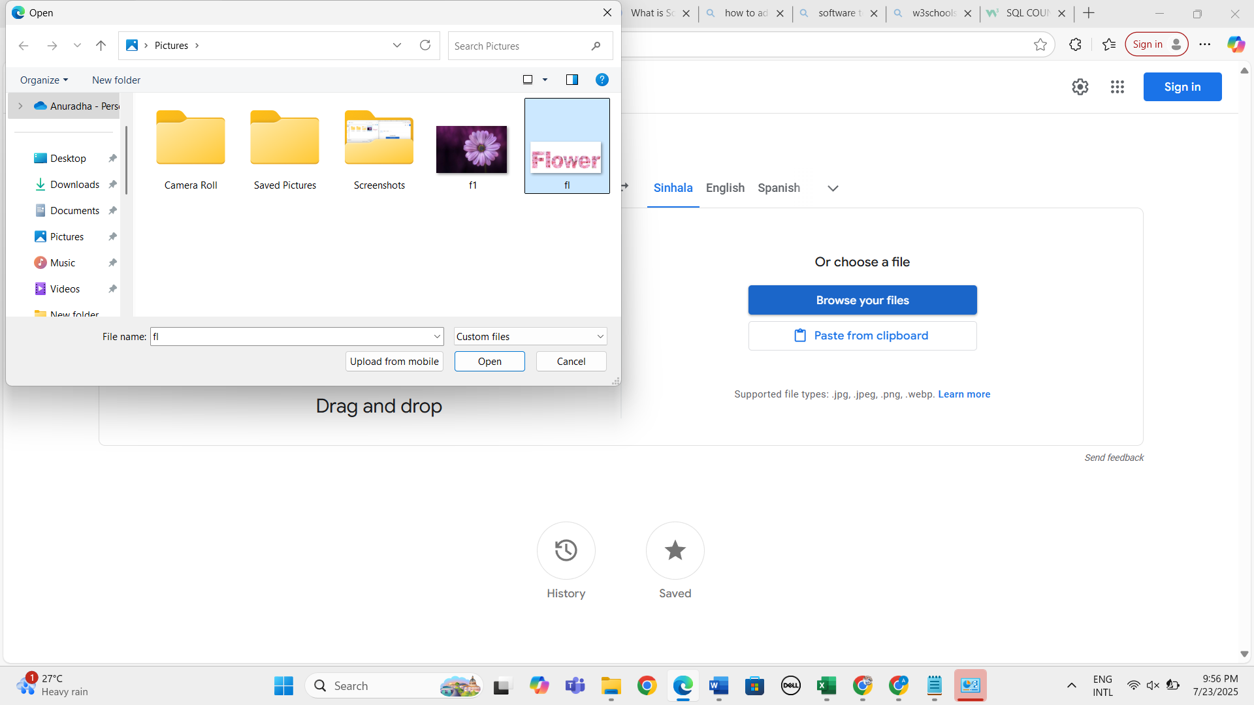
31. Verify whether uploaded images display in left hand side tile 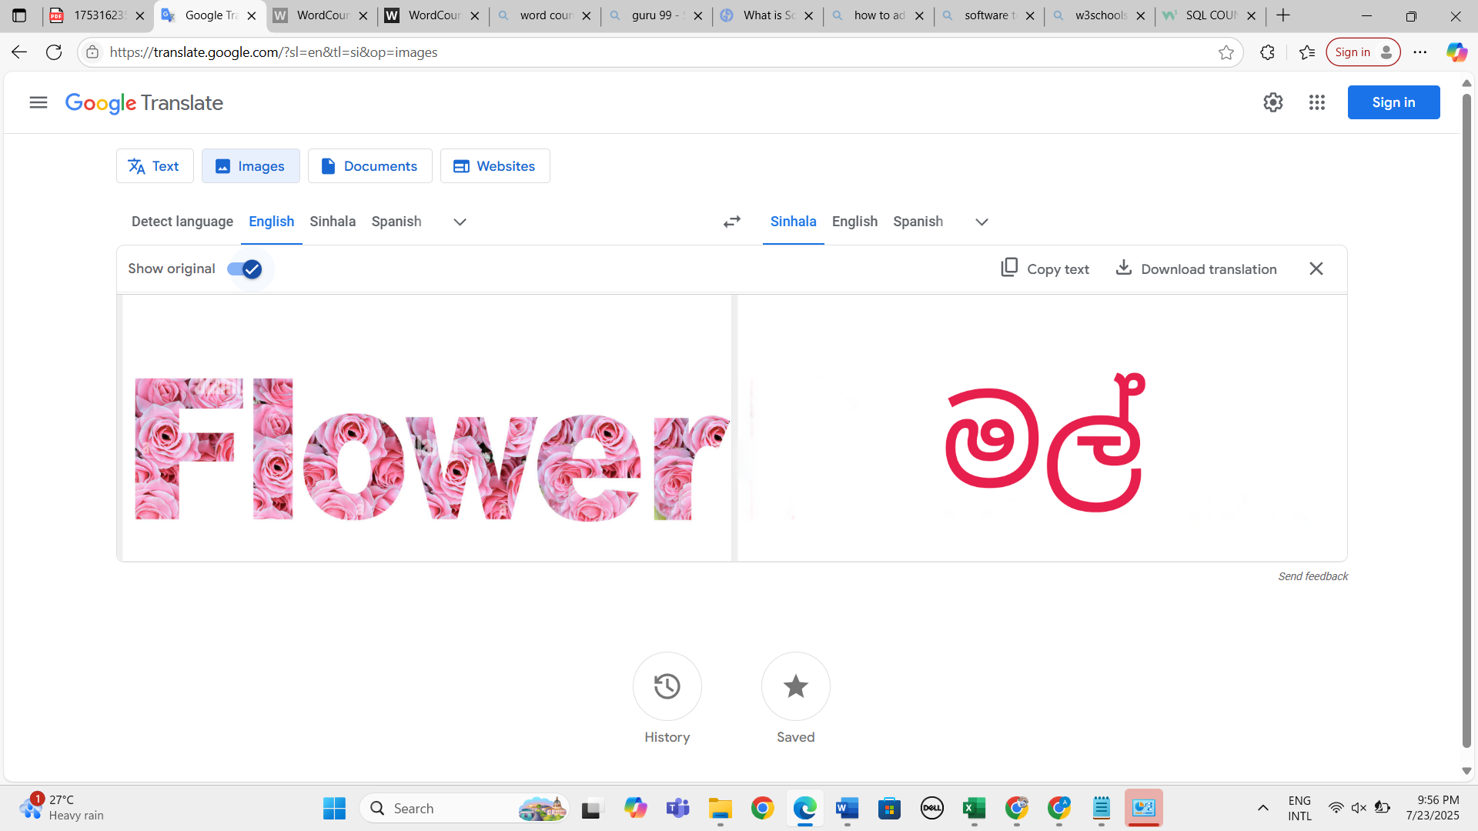
32. Verify whether system detect and translate the image content correctly 
33. Verify whether user can input image to check translation functionality by clicking upon "paste from clipboard" button 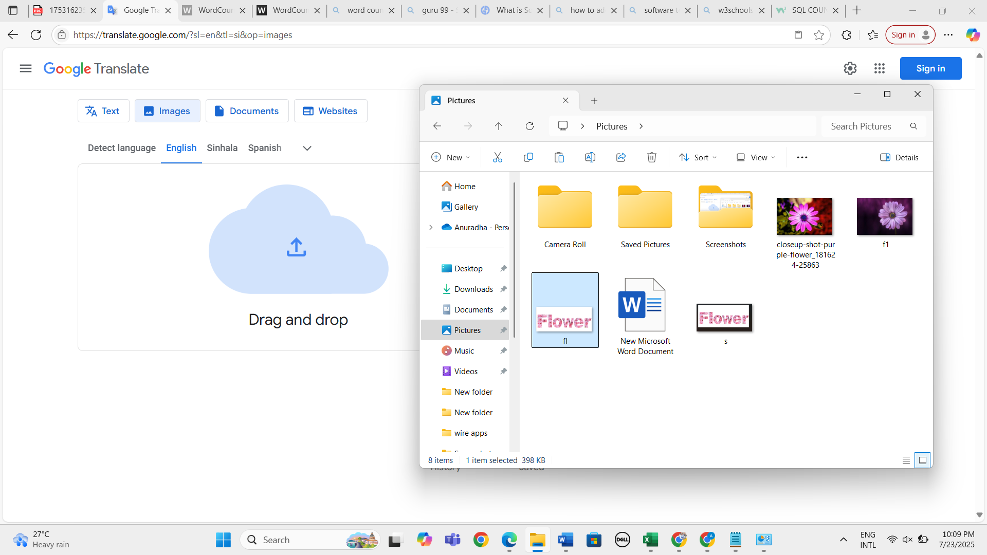
34. Verify whether user can input document to check translation functionality by performing drag and drop functionality clicking upon "cloud icon 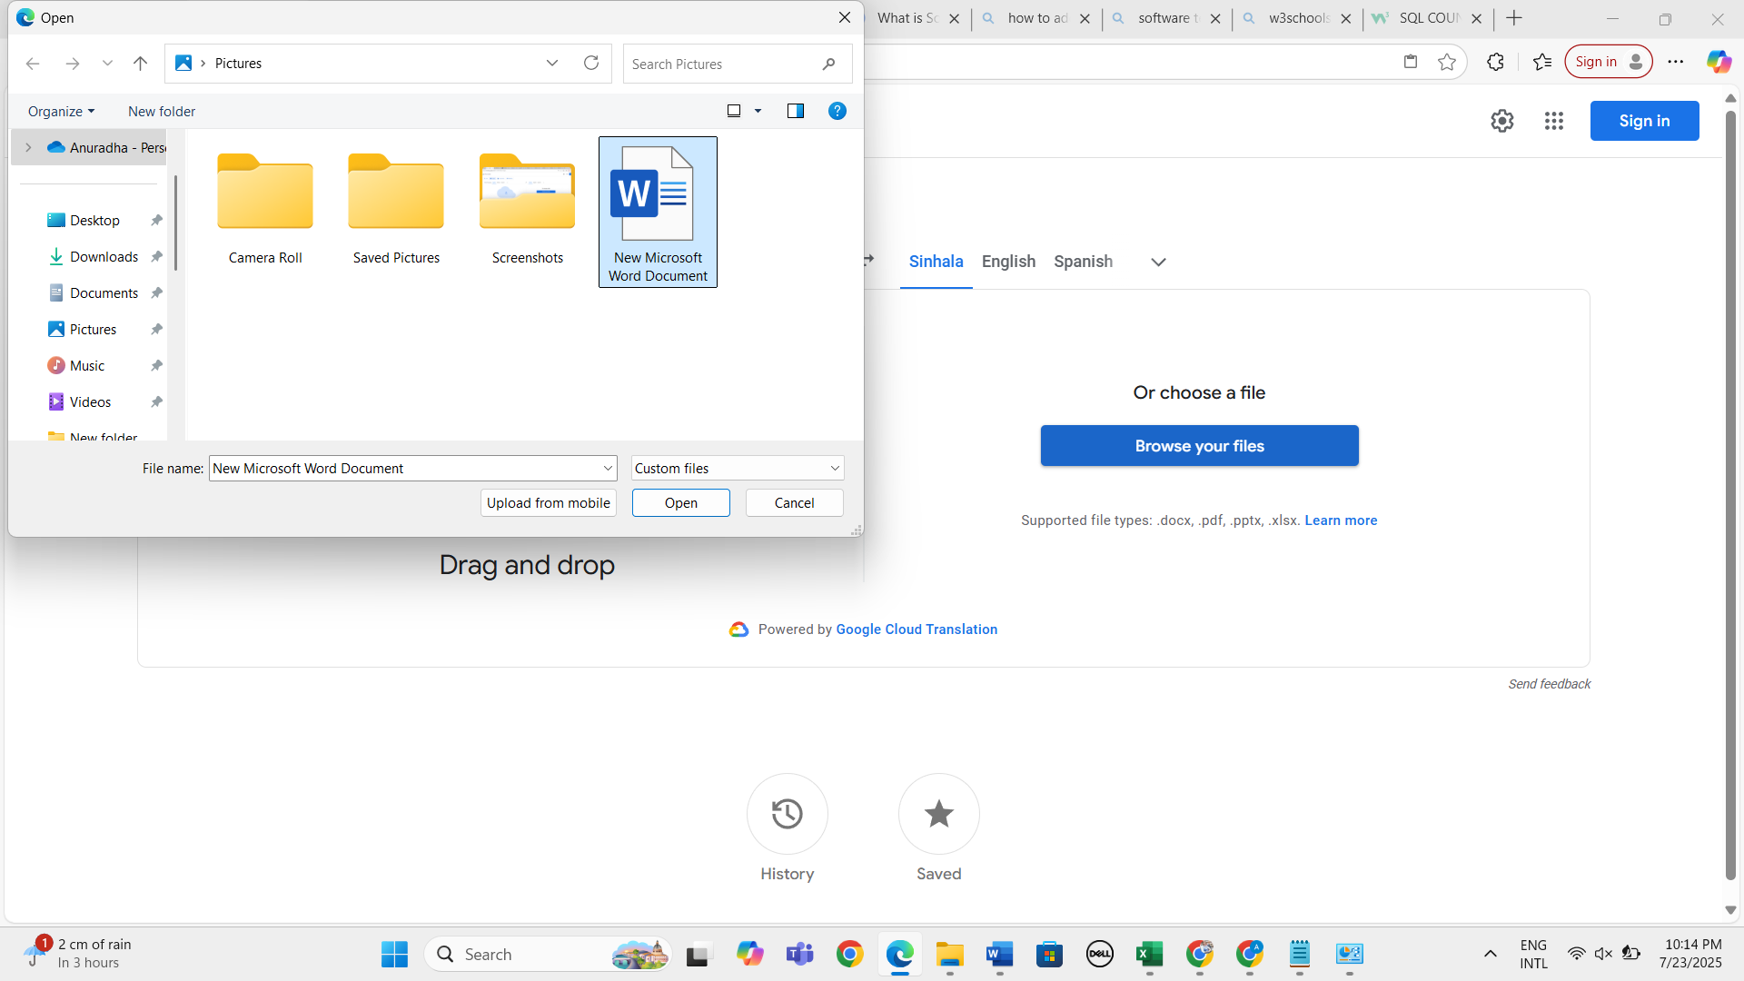
35. Verify whether user can input document to check translation functionality by clicking upon "cloud icon 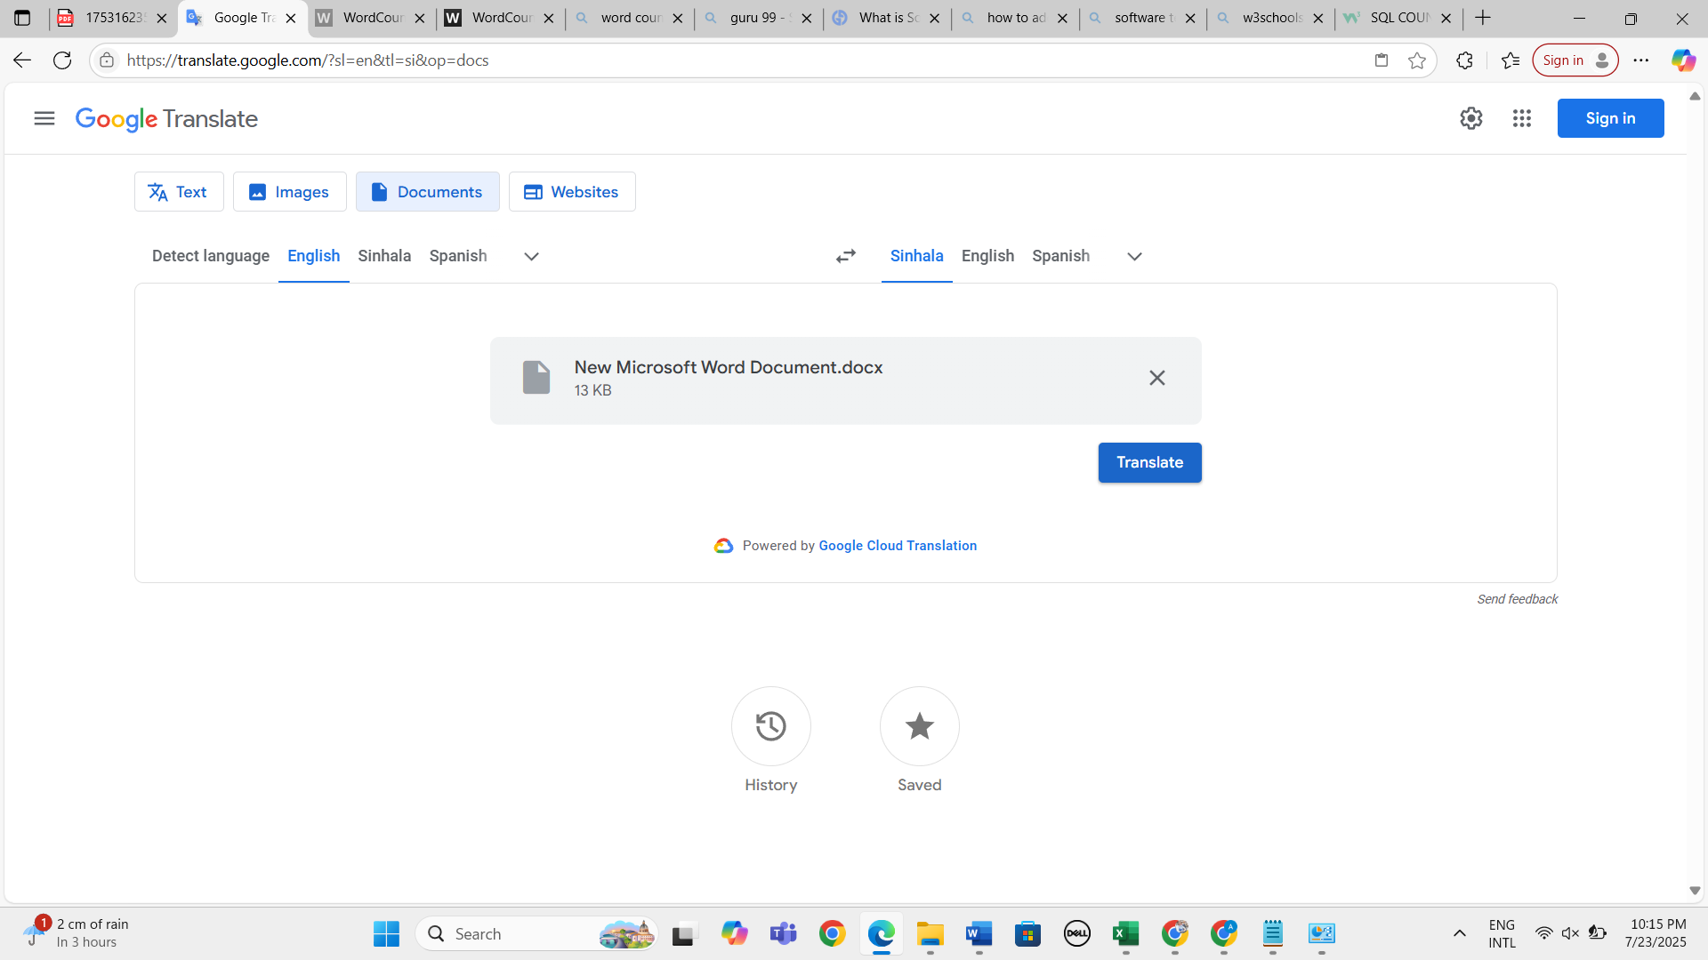 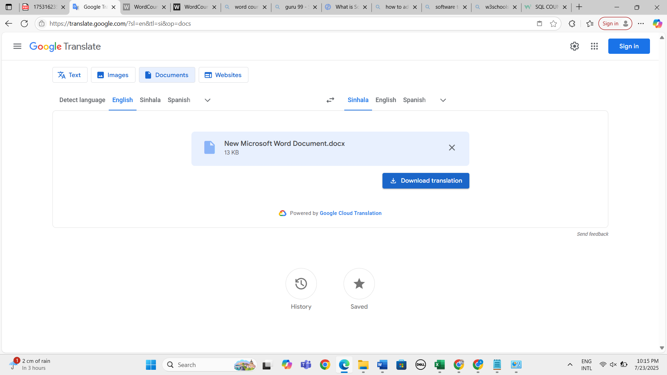
36. Verify whether user can input document to check translation functionality by clicking upon "cloud icon 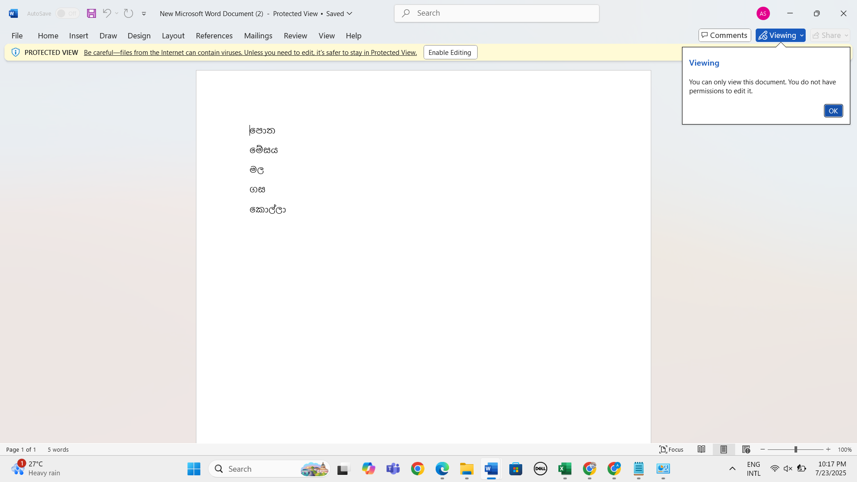
37. Verify whether user can input document to check translation functionality by clicking upon "browse your files" button 
38. Verify whether user can input voice to check the translation functionality
39. Verify whether system correctly detected given voice input
40. Verify whether system correctly translate given voice input in to selected language
41. Verify whether user can perform translation functionality by selecting "web sites" tab 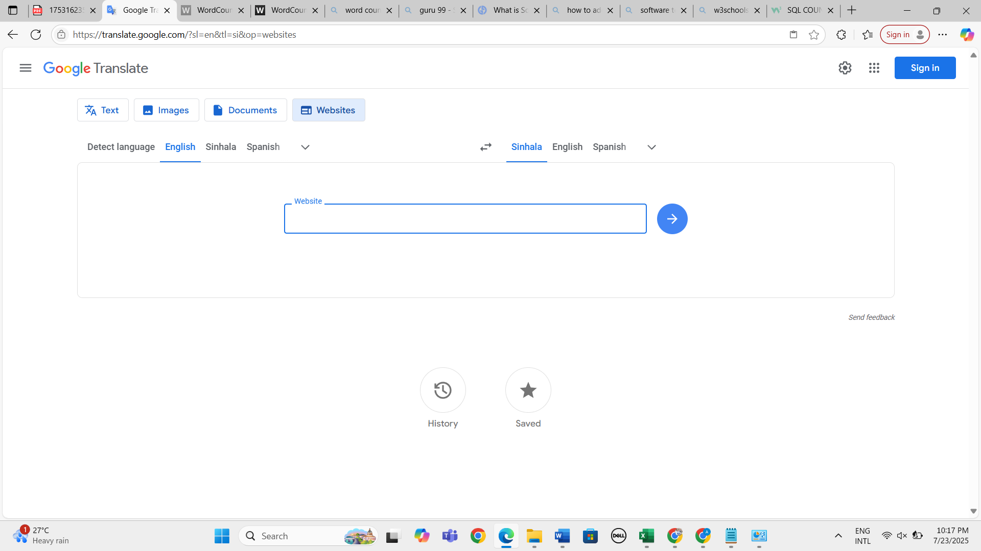
42. Verify whether system navigate to given URL and translate the web page based on the given language 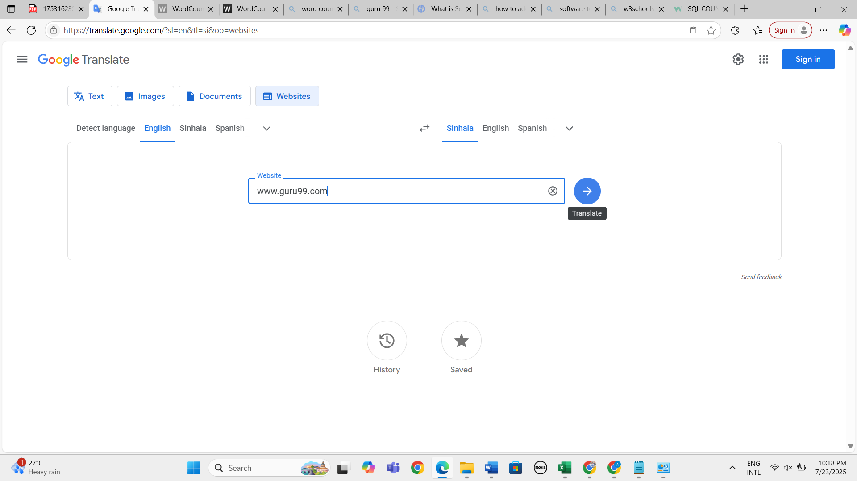 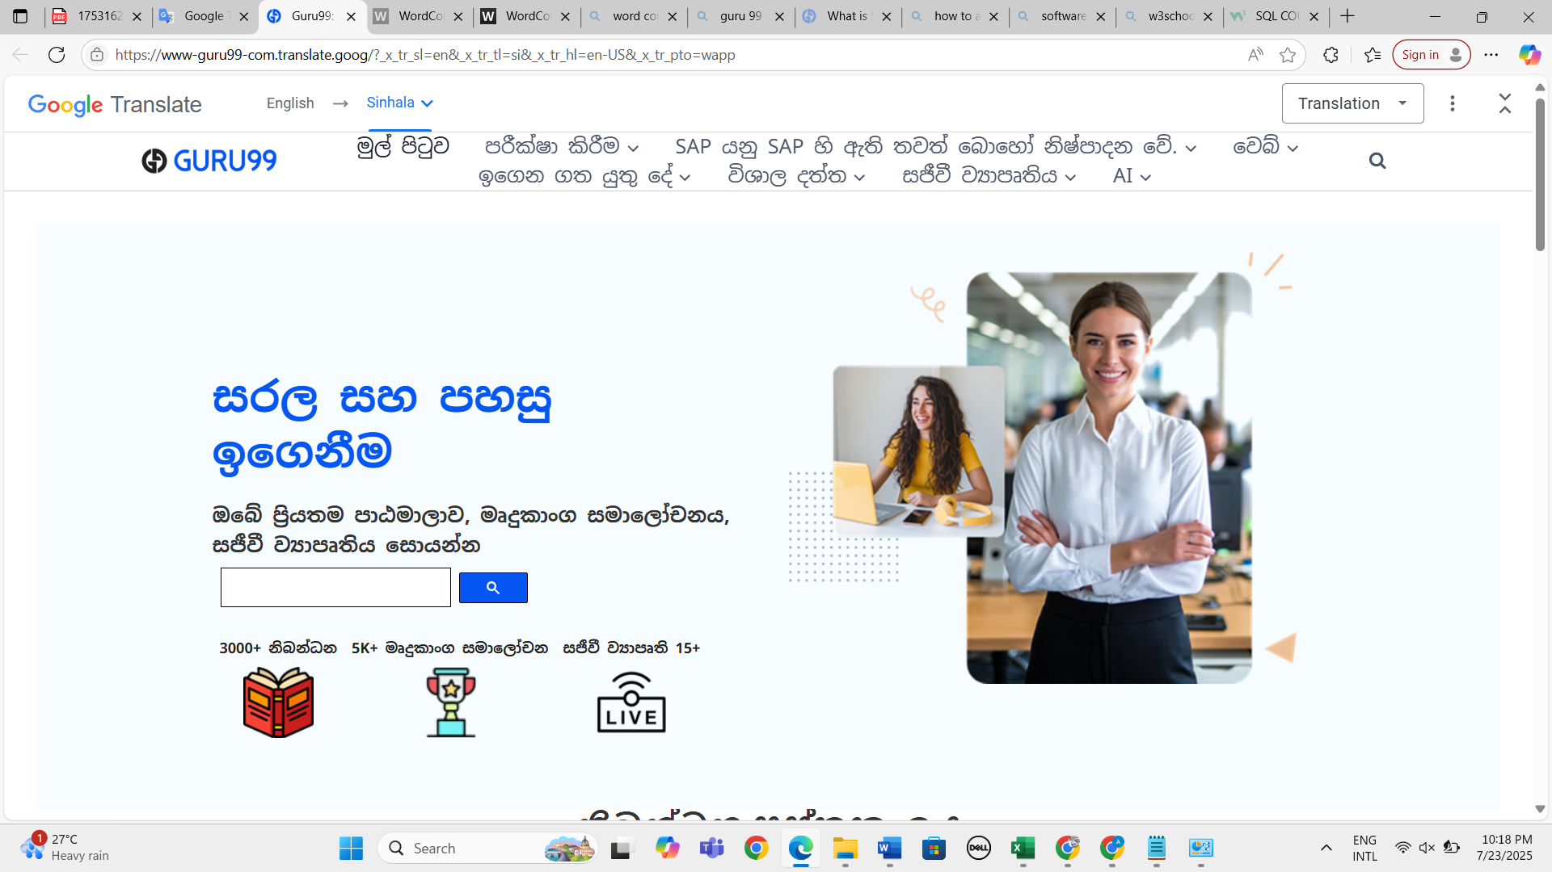
43. Verify the response time
44. Verify the status code